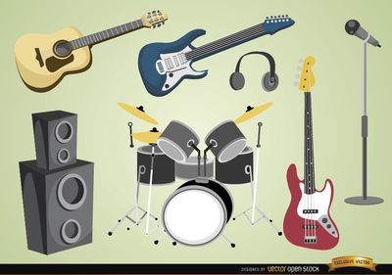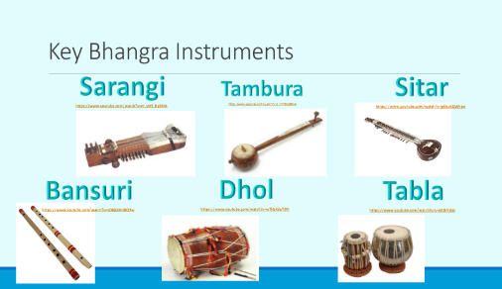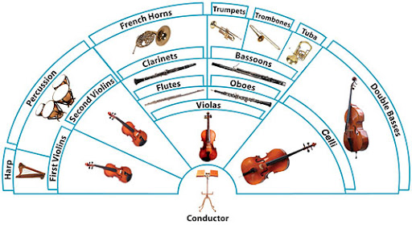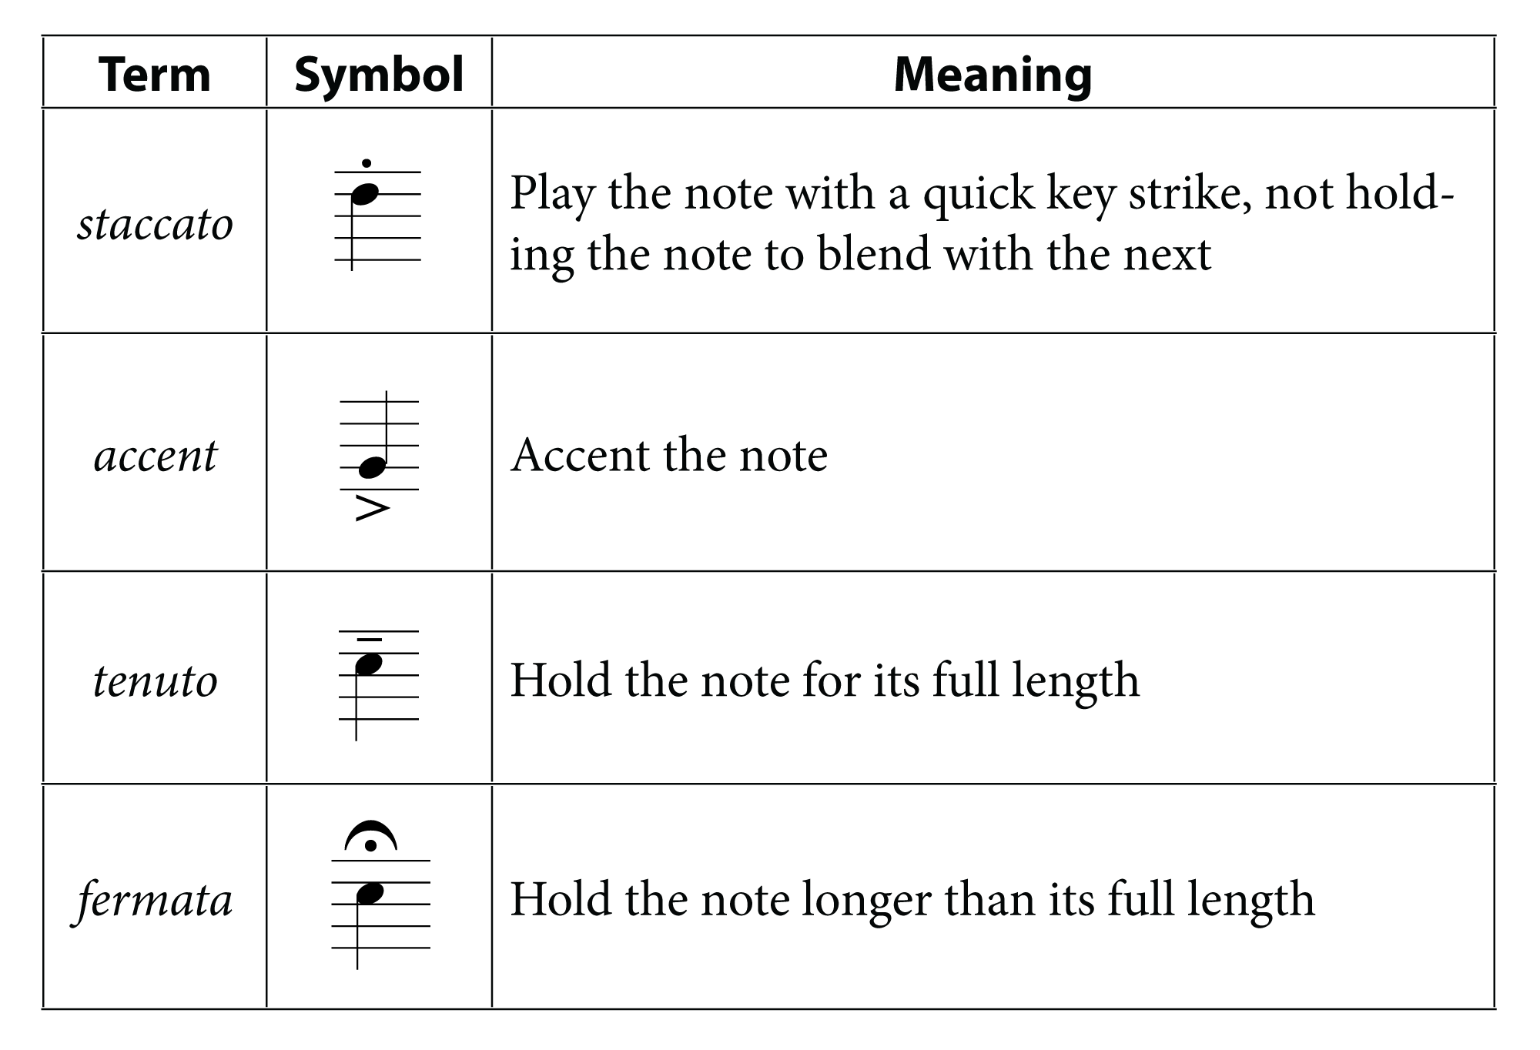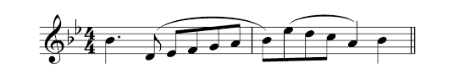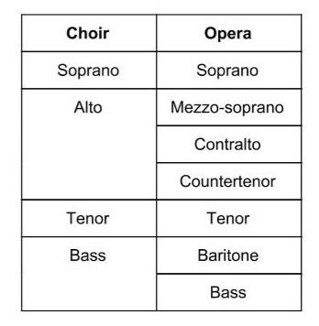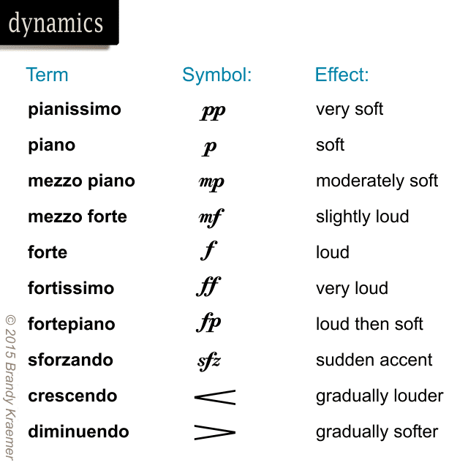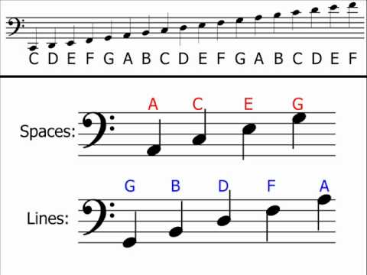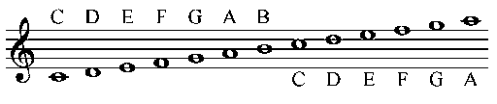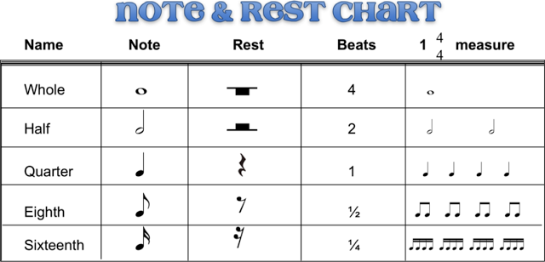s



Consonant – Notes that belong to a key/chord to produce nice harmonies

Dissonant – Notes that sound ‘wrong’ together

Cadences – These end phrases/sections of music:

Perfect Cadence (finished), Plagal Cadence (amen),

Imperfect Cadence (unfinished), Interrupted Cadence (unfinished)

Modulation – Change of key

Pedal – A sustained note, usually dominant or tonic.

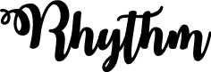

Note values e.g. crotchet, quaver, minim, semibreve.

Dotted rhythms

Polyrhythms – Two or more independent rhythms.

Syncopation – beats played on the weaker beats of the bar; off-beat.

Ostinato/Loop/Repetition – Repeated Patterns of music.

Phrase length and shape (arch shape, spiky shape).



Conjunct- Step/next door notes.

Disjunct- Hop/skip notes

Scalic – descending/ascending within a scale.

Interval – Distance between two notes.

Chromatic – notes that don’t belong to a key.

Glissando – Rapid scalic movement on an instrument.

Ostinato – Repeated melodic pattern.

Sequence – Repeated pattern at a higher or lower pitch.

Riff/motif – A short, repeated pattern, often in the bass part.

Melisma – Several notes for one syllable.

**Year 11 Term 4**



Monophonic- One melody line

Homophonic- Two melodic lines

Polyphonic- Many melodic lines

Melody and Accompaniment

Unison

Call and Response



Legato- Smooth

Staccato- Short

Accent- Forcefully

Tenuto- Sustained



Major

Minor

Chromatic

Pentatonic



Presto – Very fast

Allegro – Fast

Vivace – Fast, lively

Allegretto – Moderately quick, cheerful

Moderato – Moderato

Adagio- Slow

Largo- Very slow



Intro

ABA – Ternary AB – Binary

ABACA – Rondo AA1A2A3 - Variation

Bridge

Middle Eight (C)

Outro/Coda

Strophic – Term used to describe Verse/Chorus structure



Fortissimo (ff) – Very loud

Forte (f) – Loud

Mezzo Forte (mf) – Moderately loud

Mezzo Piano (mp) – Moderately quiet

Piano (p) – Quiet

Pianissimo (pp) – Very quiet

Crescendo (Cresc.) – Gradually get louder

Diminuendo (Dim.) – Gradually get quieter