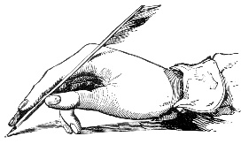
Name:___________________________________
Never Heard the Word – ROLES AND RESPONSIBILITIES
Role | Text Map Symbol | Responsibility
Playwright

Performer

Understudy

Light designer

Sound designer

Set designer

Costume designer

Technician

Director

Stage manager

Theatre manager

