Media Studies

Why choose Media Studies?

The media plays an increasingly important part in our lives and it is essential that everyone understands the power that the media has. This course will allow you to explore your own interests and to investigate subjects that concern you. If you are already a dedicated film buff, fascinated by celebrity images around you or interested in the way the press or reality TV shapes or destroys people’s lives, then this may well be the course for you. Please note: you do not need to have studied Media at GCSE.

Course content & Assessment
This course is available at A Level.
The course starts by studying media concepts, and applying this knowledge to a study of broadcasting, digital media and print. Afterwards you will have a chance to make your own product, for example a short film, radio broadcast or advertising campaign. Practical coursework is worth 30%. Examination sat in May/June is worth 70%.
The A-level course extends into the contexts of media production, and looks at the key debates about media effects, ownership and censorship. You will develop your knowledge of media theory, considering issues such as semiotics, gender and ethnicity issues, and genre theories. Finally, you will produce a media product linked to your own research as a piece of coursework. Practical coursework is worth 30%. Examination sat in May/June is worth 70%.

Extending Your Experience
It is essential that you have a clear understanding of a wide range of media issues. You will no longer see yourself as just another viewer or listener but begin to question and challenge the way programmes and texts are made. We hope to introduce you to a range of people who have made their career in the industry.

Entry requirements
Normally, you will be expected to have GCSE English Language or Literature at grade 5 or higher. However, it might be possible to take this course if you have GCSE English or Literature at grade 4.

Assessment
Paper 1 | Paper 2 | Non-exam assessment: Creating a cross-media production
What’s assessed  What’s assessed Section A will focus on Media Language and Media Representations. Questions in this section will test the following forms:  • advertising and marketing  • music video.  Section B will focus on Media Industries and Media Audiences. Questions in this section can test any two of the following forms:  • radio  • newspapers  • film (industries only). | What’s assessed  Questions will focus on the in-depth media forms of television, magazines and online, social and participatory media/video games. | What’s assessed  • Application of knowledge and understanding of the theoretical framework.  • Ability to create media products.
How it’s assessed  Written exam: 2 hours 30 mins  112 marks  70% of AS | How it’s assessed  How it’s assessed  • Written exam: 2 hours  • 84 marks  • 35% of A-level | How it’s assessed  • A choice of one of six annually changing briefs, set by AQA.  • 60 marks  • 30% of A-level  • Assessed by teachers  • Moderated by AQA
Questions  • A range of questions relating to an unseen source and Close Study Products.  • Two essay questions (20 marks), one of which is an extended response question. | Questions  One medium length unseen analysis question.  • Three essay questions (25 marks), one of which is an extended response question and one of which is a synoptic question. | Tasks  Students produce:  • a statement of intent  • a cross-media production made for an intended audience.

Where will this course take me?

You will learn to see the finer details in films, in television programmes, magazines and newspapers. The course will also allow you to learn more about texts that already entertain and inspire you. A Media Studies degree would help you to follow a career in Journalism, Publishing, or Broadcasting or even using digital media to facilitate marketing your own business.

Useful websites
www.johnofgauntschool.org
http://www.aqa.org.uk/subjects/media-studies

Facilities
Candidates will have access to: digital still cameras, video cameras, sound recording software and other photography equipment, as well as a suite of computers, set up with Photoshop and other editing programmes.

These Close Study Products (CSPs) have been selected for the analysis of media products as part of the A-level Media Studies course.
Questions in the A level Media Studies examinations will be based on these products. Please note, they are subject to change year on year.
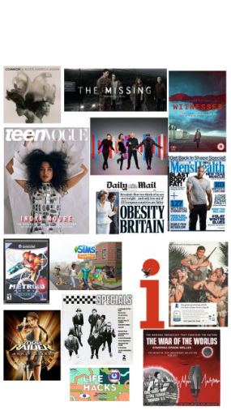

For further help or information please contact Mrs Bray or Mrs Johnson in the English and Media Studies Faculty cbray@jogschool.org

