Ethical and environmental considerations in business
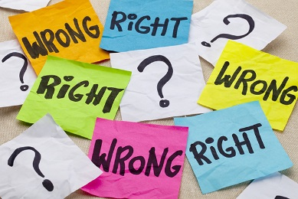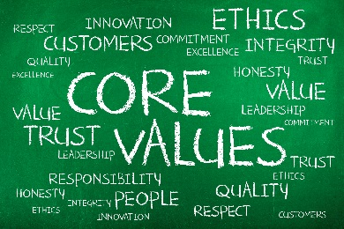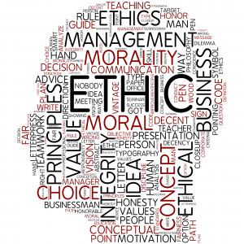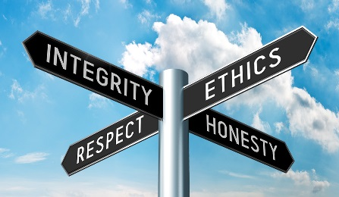

Business ethics is all about what is right/wrong, fair/unfair. There are a number of ethical issues to consider in business:
- How should workers be treated?
- How should suppliers be treated?
- How should customers be treated?
- Where should businesses source materials from?
- What marketing decisions should be made?

 | Examples of ethical / unethical practice | Benefits / drawbacks of being ethical?
Treatment of workers | - Paying fair / decent wages – not just the Minimum Wage (legal vs ethical?)  - Health & safety – keeping workers safe  - Work-life balance – too many hours vs not enough (zero-hour contracts?)  - Perks and benefits – e.g. staff discount & health insurance  - Discrimination; e.g. age, race & gender  Examples discussed in class:  - [Sports Direct] [Expedia] | - Recruitment – easier to attract good quality employees  - Retention – easier to keep good employees / labour turnover  - Motivation – staff want to work harder/longer/fewer absences  - Costs (for good pay, training, safety & perks) = a) profits, or b) prices for customers, or c) budgets in other areas of the business e.g. Marketing.
Treatment of suppliers | - Paying suppliers on time / delaying payment  - Paying a ‘fair’ price – large businesses might abuse their size & power over small suppliers to get very low prices  - Charging suppliers for shelf space  - Unfair penalties & fines to suppliers  Examples discussed in class:  - Tesco [BBC] [Guardian] [Telegraph]  - UK milk suppliers [Guardian] | - Develop a good relationship with suppliers = might get lower prices, faster deliveries, better payment terms (e.g. 60 days credit)  - Develop a good brand image – poor treatment of suppliers can be reported in the news  - costs to pay a ‘fair’ price = profits, or prices for customers  - Cash flow problems – might not have enough spare cash if you’ve paid the supplier promptly
Treatment of customers | - Charging fair prices for satisfactory quality products / service.  - Price fixing – collusion with competitors  - Ensuring customer safety – prompt product recalls where needed  - Prompt deliveries  - Deal with problems quickly & fairly  Examples discussed in class:  - Supermarket price fixing [Guardian]  - Failure to recall faulty cars [Guardian] | - Customer satisfaction = brand loyalty = repeat customers sales revenue  - Good brand image = attracts new customers  - Higher costs (to ensure safety, prompt deliveries, and good customer service) = profit
Sourcing of materials | - Using sustainable materials – e.g. cod, wood  - Human rights abuses  - Fairtrade  Examples discussed in class:  - Primark [Daily Mail]  - Ikea [Virgin] | - Good brand image = attract & retain customers = revenue  - Unique Selling Point (USP) = stand out from competitors  - Some customers may be willing to pay more = revenue (but not necessarily more profit, as costs also likely to be higher)  - Cost of materials likely to be higher
Marketing decisions | - Misleading customers about prices & special offers  - Claiming health benefits that don’t exist / haven’t been proven  - Targeting children in advertising  - The Advertising Standards Authority oversees advertising in the UK to make sure it is done fairly.  Examples discussed in class:  - [Volkswagen] [Activia & Walmart] | - Good brand image = attract & retain customers = revenue  - Might not be able to persuade as many people to buy products / services if you cannot mislead / exaggerate = revenue

BB Toys plc
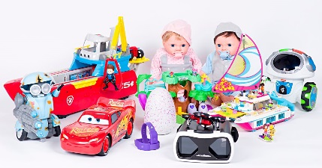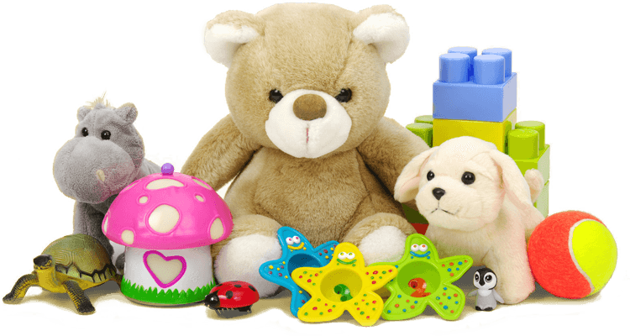
BB Toys plc manufactures a range of toys, which it sells in bulk to retailers such as WH Smith and Smyths Toys. The business started in 1995 and had a number of successful years. However, due to increased competition in the market, the business has failed to make a profit since 2015. In order to improve profits, BB Toys plc have taken the following three steps:
- Step 1: Moved production from the UK to China in 2019, in order to reduce production costs. Labour costs are over 50% lower, and Employment, and Health and Safety laws are much more relaxed. Finished toys are then shipped back to retailers in the UK.
- Step 2: Delayed payment to suppliers: they now take 6 months to settle invoices, and threaten to use other suppliers if they complain. Small suppliers have been told they will receive 10% less than before.
- Step 3: Switched to the cheapest materials wherever possible (Fairtrade/sustainable materials are too expensive).
Year | Profit / Loss
2015 | +£1.2
2016 | -£1.1m
2017 | -£2.4m
2018 | -£3.5m
2019 | -£5.1m
2020 (predicted) | +£1.5m

Exam style questions (answer in your book / on lined paper):
- Explain one way in which BB Toys plc could be described as an ‘unethical’ business. [3]
- Analyse one benefit and one drawback of Step 1 to BB Toys plc. [6]
- With reference to Step 1 only; evaluate whether BB Toys plc was right to move production to China to improve the profitability of the business. [9]

