GCSE Business
Revision booklet
Business 2: Operations, Finances & Influences on Business

- The Business 2 exam is worth 50% of your GCSE.
- The exam is worth 80 marks and will last for 1 hour & 30 minutes.
- The Business 2 exam covers the following topics (this booklet focuses just on Finance):

Business 2: Operations, Finance, Influences on business, and The interdependent nature of business
4. Operations | 4.1 Production processes  4.2 Quality of goods and services  4.3 The sales process and customer service  4.4 Consumer law  4.5 Business location  4.6 Working with suppliers
5. Finance | 5.1 The role of the finance function  5.2 Sources of finance  5.3 Revenue, costs, profit and loss  5.4 Break-even  5.5 Cash and cash flow
6. Influences on business | 6.1 Ethical and environmental considerations  6.2 The economic climate  6.3 Globalisation
7. The interdependent nature of business

You should prepare for the exam using the following resources:
- Practise using past exam papers and mark schemes.
- Look back at mistakes you have made on assessments and ‘fix’ them.
- Look at the model answers available.
- Fully complete this revision booklet (and the self-audit at the back).
- Ask your teacher for help.

5.1 The role of the finance function
The role of the finance department includes…
………………………………………………………………………………………………………………………………………………………………………
………………………………………………………………………………………………………………………………………………………………………
………………………………………………………………………………………………………………………………………………………………………
………………………………………………………………………………………………………………………………………………………………………

5.2 Sources of finance
Complete the two tables below about sources of finance (internal & external):
Source of Finance (Internal) | Definition / explanation, benefits & drawbacks
Owner’s capital
Retained profit
Sale of assets

Source of Finance (External) | Definition / explanation, benefits & drawbacks
Bank loan
Overdraft
Take on a new partner
Share issue
Crowd funding
Trade credit

5.3 Revenue, costs, profit and loss
Fill in the four blanks (shaded squares) below:

Complete example |  |  | Fill the blanks… |  |  | Fill the blanks…
Hats Ltd |  |  | Chairs Ltd |  |  | Stools plc
 | £ |  |  | £ |  |  | £
Revenue | 200,000 |  | Revenue | 50,000 |  | Revenue | 100,000
Cost of sales | 80,000 |  | Cost of sales | 10,000 |  | Cost of sales | 60,000
Gross Profit | 120,000 |  | Gross Profit | 40,000 |  | Gross Profit | 40,000
Rent | 20,000 |  | Rent | 10,000 |  | Rent & bills | 10,000
Salaries | 40,000 |  | Salaries | 10,000 |  | Wage/salaries | 10,000
Bills | 20,000 |  | Bills | 5,000 |  | Staff training | 20,000
Advertising | 10,000 |  | Distribution | 5,000 |  | Advertising | 20,000
Net Profit | 30,000 |  | Net Profit | 10,000 |  | Net Profit | (20,000)

What could Stools plc do to improve their gross profit? Explain your idea and any drawbacks / limitations:
………………………………………………………………………………………………………………………………………………………………………
………………………………………………………………………………………………………………………………………………………………………
………………………………………………………………………………………………………………………………………………………………………
………………………………………………………………………………………………………………………………………………………………………

What could Stools plc do to improve their net profit? Explain your idea and any drawbacks / limitations:
………………………………………………………………………………………………………………………………………………………………………
………………………………………………………………………………………………………………………………………………………………………
………………………………………………………………………………………………………………………………………………………………………
………………………………………………………………………………………………………………………………………………………………………

Why is it important for businesses to make a profit?
………………………………………………………………………………………………………………………………………………………………………
………………………………………………………………………………………………………………………………………………………………………
………………………………………………………………………………………………………………………………………………………………………

Calculate the Gross Profit Margin for Hats Ltd:
………………………………………………………………………………………………………………………………………………………………………
………………………………………………………………………………………………………………………………………………………………………

Calculate the Net Profit Margin for Hats Ltd:
………………………………………………………………………………………………………………………………………………………………………
………………………………………………………………………………………………………………………………………………………………………

What are the three steps in calculating the Average Rate of Return (ARR)?

Step 1
Step 2
Step 3

Calculate the Average Rate of Return (ARR) for the following investment:

Initial Investment | (£50,000)
Income Year 1 | £20,000
Income Year 2 | £40,000
Income Year 3 | £50,000

Step 1
Step 2
Step 3
Final Answer

5.4 Break-even
Imagine that you run a small factory that makes wooden toys such as trains.
- You sell each train for £10.
- Each train costs you £5 to make in materials (e.g. wood).
- The fixed costs for the factory are £10,000 per month.

Using an example from your toy factory, explain the term ‘revenue’.
………………………………………………………………………………………………………………………………………………………………………
………………………………………………………………………………………………………………………………………………………………………
………………………………………………………………………………………………………………………………………………………………………
Using an example from your toy factory, explain the term ‘fixed costs’.
………………………………………………………………………………………………………………………………………………………………………
………………………………………………………………………………………………………………………………………………………………………
………………………………………………………………………………………………………………………………………………………………………
Using an example from your toy factory, explain the term ‘variable costs’.
………………………………………………………………………………………………………………………………………………………………………
………………………………………………………………………………………………………………………………………………………………………
………………………………………………………………………………………………………………………………………………………………………

Using the figures above, calculate the break-even point for your toy factory:

………………………………………………………………………………………………………………………………………………………………………
………………………………………………………………………………………………………………………………………………………………………
………………………………………………………………………………………………………………………………………………………………………

Using the figures above, draw a break-even chart which shows the fixed costs, total costs, total revenue and break-even point:

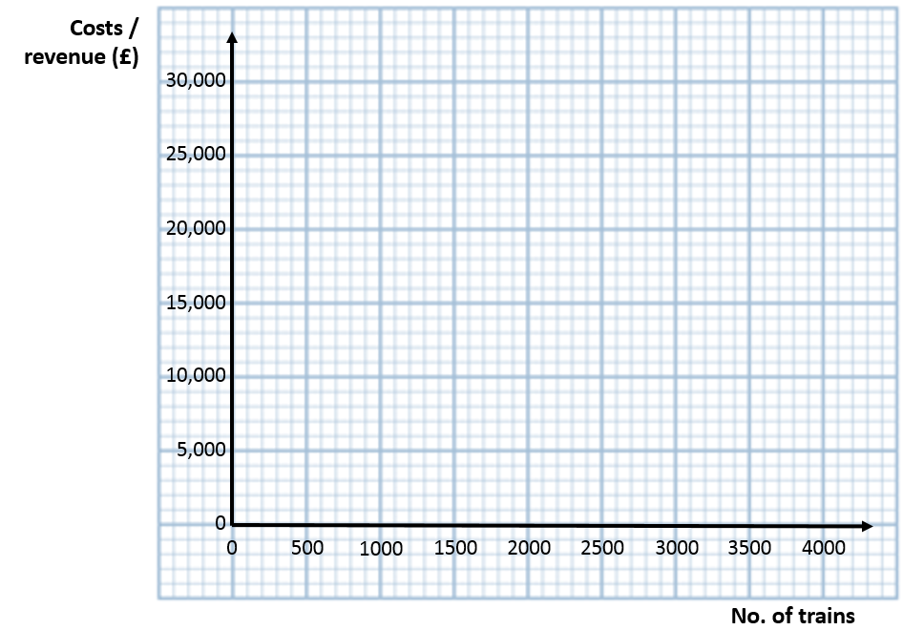
Imagine your business is currently selling 3,000 trains per month:

- How much profit / loss is being made?

………………………………………………………………………………………………………………………………………………………………………
………………………………………………………………………………………………………………………………………………………………………
- What is the margin of safety?

………………………………………………………………………………………………………………………………………………………………………
………………………………………………………………………………………………………………………………………………………………………
Identify and explain two limitations of using break-even charts / analysis:
………………………………………………………………………………………………………………………………………………………………………
………………………………………………………………………………………………………………………………………………………………………
………………………………………………………………………………………………………………………………………………………………………
………………………………………………………………………………………………………………………………………………………………………

5.5 Cash and cash flow
Explain the importance of cash to a business (or the consequences of not having enough):
………………………………………………………………………………………………………………………………………………………………………
………………………………………………………………………………………………………………………………………………………………………
………………………………………………………………………………………………………………………………………………………………………
………………………………………………………………………………………………………………………………………………………………………

What is the difference between cash and profit?

Cash
Profit

Explain the benefits to a business of creating a cash flow forecast:
………………………………………………………………………………………………………………………………………………………………………
………………………………………………………………………………………………………………………………………………………………………
………………………………………………………………………………………………………………………………………………………………………
………………………………………………………………………………………………………………………………………………………………………

Complete the blanks in the following cash flow forecast:

 | January | February | March
 | £ | £ | £
Opening balance | 10,000 | 10,500
Cash inflow | 2,000 | 3,000 | 4,000
Cash outflow | 1,500 | 2,000
Net cash flow | 500 |  | 1,500
Closing balance |  | 11,500 | 13,000

Self-audit
Give yourself an honest rating on each area of the syllabus, so that you know where to prioritise your revision (e.g. 1-5 ):

- Finance
Topic
- Content
- Points to include
5.1 The role of the finance function
- The purpose of the finance function
- provide financial information, support business planning and decision making
- The influence of the finance function on business activity
5.2 Sources of finance
- The reasons businesses need finance
- establishing a new business, funding expansion, to run the business recruitment, marketing
- Ways of raising finance
- loan, overdraft, trade credit, retained profit, sale of assets, owners’ capital, new partner, share issue, crowdfunding
- How and why different sources of finance are suitable for new and established businesses
5.3 Revenue, costs, profit and loss
- The concept of revenue, costs and profit and loss in business and their importance in business decision-making
- The different costs in operating a business
- fixed, variable, total
- Calculation of costs and revenue
- Calculation of profit/loss
- gross profit, net profit
- Calculation and interpretation of profitability ratios
- gross profit margin, net profit margin
- Calculation and interpretation of average rate of return
5.4 Break-even
- The concept of break-even
- total costs = total revenue
- Simple calculation of break-even quantity
- The usefulness of break-even in business decision-making
- informs marketing and planning decisions
5.5 Cash and cash flow
- The importance of cash to a business
- providing liquidity, enables business to meet short-term debts/expenses
- The difference between cash and profit
- The usefulness of cash flow forecasting to a business
- planning tool, anticipates periods of cash shortage, enables remedies to be put in place for shortages, provides targets
- Completion of cash flow forecasts

