Paper 1 – B5 Homeostasis

FOLD OVER TO TEST YOURSELF →→→→

Key Vocabulary | Definition
Homeostasis | The regulation of internal conditions to ensure they are kept at the optimum level for function
Hormones | Chemical messengers sent to glands in the blood
Optimum | The “best” level
Conscious | Actions that require impulses sent to the brain, you have to think about them
Unconscious | Faster actions that do not require thinking, sent to the spinal cord

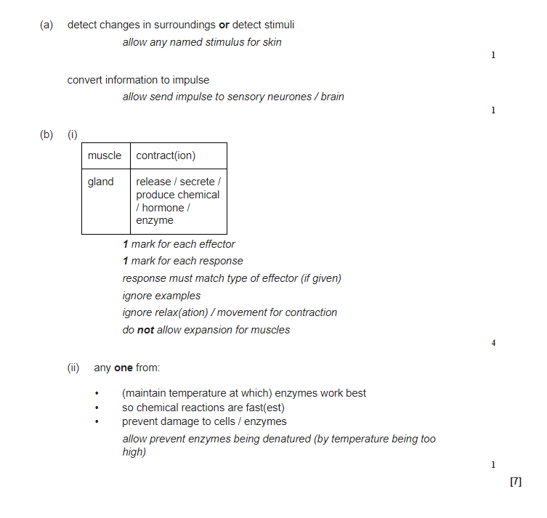
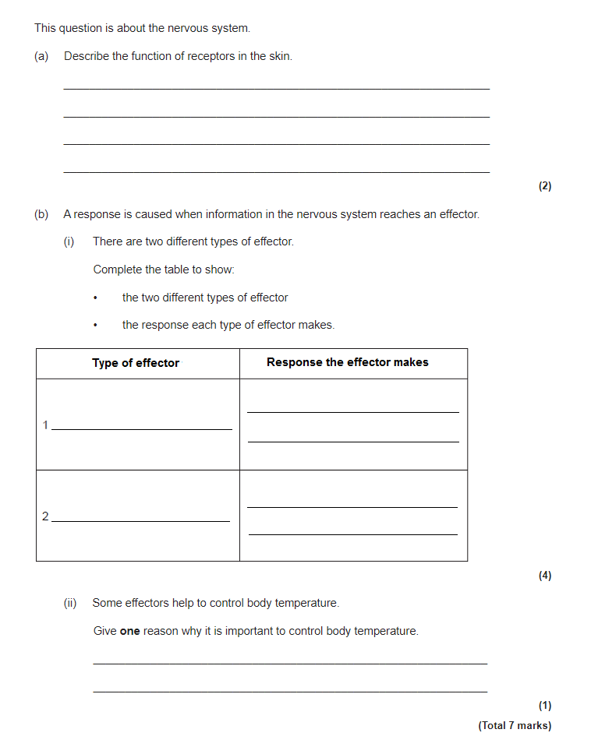

Task | Link to resource | QR Code
Use the following link to revise homeostasis | https://www.youtube.com/watch?v=XMsJ-3qRVJM
Use the following link to revise the nervous system | https://www.youtube.com/watch?v=HiuXfbwND9s
Use the following link to revise the endocrine system | https://www.youtube.com/watch?v=BvpPCn1rwsw
Watch the following video on the reaction speed required practical and take notes | https://www.youtube.com/watch?v=Fm02i4vEi5Q

