Paper 1 – P3 Particle Model

Key Vocabulary | Definition
Solid | The state of matter in which particles are tightly packed and vibrate about a fixed point
Liquid | The state of matter in which particles are tightly packed and flow over each other randomly
Gas | The state of matter in which particles are spread apart and move freely in random directions
Density | The amount of mass per unit volume
Specific Heat Capacity | The amount of energy required to raise one kilogram of a material by 1 degree Celsius
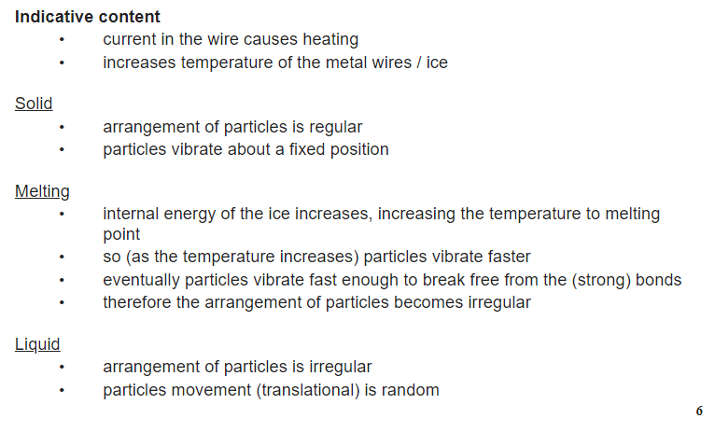
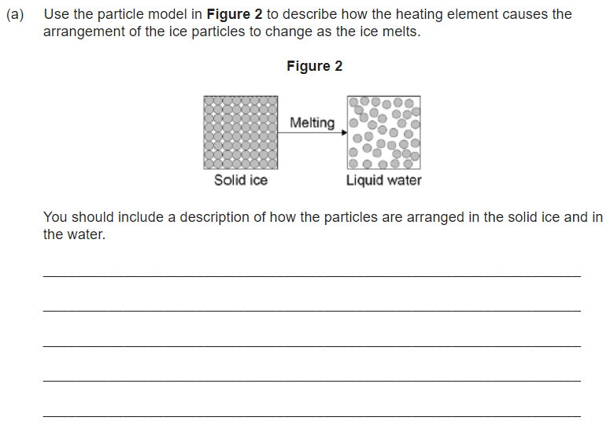
FOLD OVER TO TEST YOURSELF →→→→

Task | Link to resource | QR Code
Watch the video summary of the particle model unit | https://www.youtube.com/watch?v=vtuw9Ib1c3E
Answer the quickfire questions | https://www.bbc.co.uk/bitesize/topics/z48v46f/articles/zbstfdm
Answer the exam-style questions | https://www.bbc.co.uk/bitesize/topics/z48v46f/articles/znxd7v4

