
Lasagne

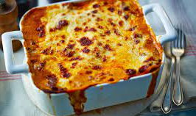
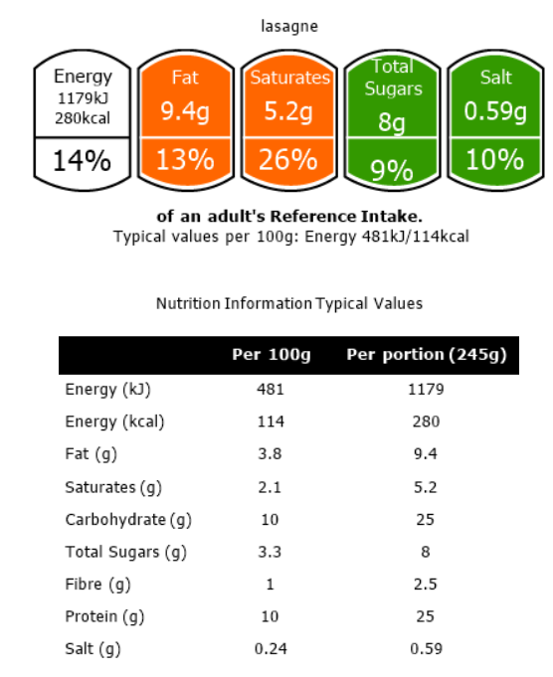

https://www.youtube.com/watch?v=GK7GObLUCWU – 5.06 minutes – Jamie Oliver
Oven proof dish & Apron / Hair Tie
No nuts or nut-based ingredients
- 1 onion
- 1 can tomatoes
- 2 tbsp tomato puree
- 1 packet minced meat or 8oz (200g) soaked lentils / Quorn
- 1 beef or vegetable stock cube
- 75g cheese (or low fat cheese – optional)
- 1 jar white sauce / lasagne sauce
- Lasagne sheets / pasta (whole-wheat is a higher fibre option)
- Optional extras – carrot, celery, mushroom, peppers, herbs, garlic, courgette, etc.

- Peel, chop, slice, grate all vegetables and place into a large bowl.
- Put the meat into the large saucepan and cook over a medium/low heat until it turns golden brown. (Maillard Reaction)
- Drain off any excess fat – if needed!
- Using the same pan you are cooking the meat, add the vegetables and fry (except for the garlic) until they are tender (10 minutes).
- Add the garlic and fry for a further 1-minute.
- Crumble in the stock cube, tomato puree, canned tomatoes, herbs and ¼ - ½ pint of water.
- Cook for at least 20 minutes over a low heat.
Assembling
- Arrange layers of meat sauce and pasta in your ovenproof dish.
- Finish the top with the white sauce.
- Cool and cover with tin foil / cling film.
- AT HOME - Bake at 180°C for 20 – 30 minutes. (If the top is browning too soon cover with foil)

Never assume a pan handle is cold!
You cannot tell by looking at it!

When cooking we are assessing the skills the students are using and mastering. The skills this recipe focusses upon are –

Transferring and embedding skills, simmering, knife skills (brunoise, macedoine, bridge, claw) draining, using the hob correctly and safely, handling and cooking high risk ingredients, testing for readiness, maillard reaction, rendering fat, layering, assembling, following written instructions, washing and drying equipment, independence.

Breads of The World - 1
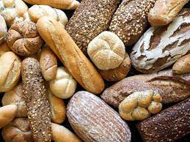

https://www.youtube.com/watch?v=MWI1bZ68e64 – Focaccia art
https://www.youtube.com/watch?v=NdTAcAgOONw – Shaping bread rolls https://www.wikihow.com/Knead-Dough - How to knead dough
Container /oven tray & Apron / Hair Tie
No nuts or nut-based ingredients
Plain White Bread
- 600 g strong bread flour
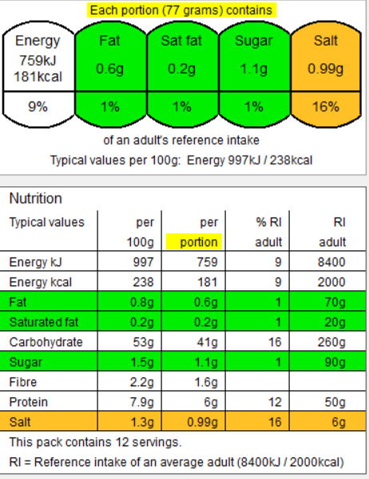
- 400 ml tepid water
- 2x 7 g sachets of dried yeast
- 1 tablespoons sugar
- 1 level tablespoon salt
- flour, for dusting

1) Pre-heat the oven to 50°C / gas mark 1.
2) In a large bowl put ALL of the; sugar, salt, oil, yeast and
water but only HALF of the flour.
3) Mix using the wooden spoon for 5 minutes.
4) Add the other HALF of flour and stir in. You may need to
either add more warm water OR more flour in order to
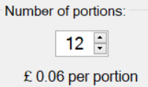
make a slightly sticky but firm dough.
5) Knead on a floured table for 15 minutes.
6) Add your flavours and shape your bread – think evenly
When cooking we are assessing the skills the students are using and mastering. The skills this recipe focusses upon are –
Transferring and embedding skills, knife skills (even sized chunks appropriate for cooking time, julienne, bridge, claw), using the oven correctly and safely, grating, preparing vegetables, handling dough, rolling, shaping and moulding, proving, yeast-based dough, quality and evenness, testing for readiness, following written instructions, washing and drying equipment, independence.

shaped rolls, the more detailed your design the more
complex they become in skills = higher marks.
7) Place onto a baking tray and put into the oven to prove
for as long as possible.
8) When ready to bake, remove the bread from the oven.
9) Turn the oven up to 200°C. When hot, place the bread
into the oven and place into the hot oven for 15 – 25
minutes.

Breads of The World - 2
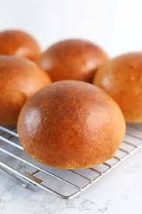
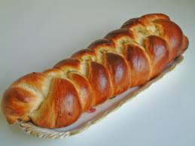
When cooking we are assessing the skills the students are using and mastering. The skills this recipe focusses upon are –
Transferring and embedding skills, knife skills (even sized chunks appropriate for cooking time, julienne, bridge, claw), using the oven correctly and safely, grating, preparing vegetables, handling dough, rolling, shaping and moulding, proving, yeast-based dough, quality and evenness, testing for readiness, following written instructions, washing and drying equipment, independence.

Brioche - France
https://www.youtube.com/watch?v=MWI1bZ68e64 – Focaccia art
https://www.youtube.com/watch?v=NdTAcAgOONw – Shaping bread rolls https://www.wikihow.com/Knead-Dough - How to knead dough
Container /oven tray & Apron / Hair Tie
No nuts or nut-based ingredients

APRON and Container / hair tie
- 320ml milk, plus extra for brushing
- 30g unsalted butter
- 600g plain flour, plus extra for dusting
- 2 tsp sugar
- 2 tsp fast-action dried yeast
- 1 egg, beaten

- Pre-heat the oven to proving temperature – 50c.
- Over a low heat - Heat the milk and butter on the hob until butter has melted and leave to cool.
- Mix HALF the flour with all the other ingredients.
- Stir for 5 minutes.
- Put in the last half of the flour and mix with spoon until it forms a ball.
- Put onto floured surface and knead for AT LEAST 10 minutes
- By hand - Roll into 4/6 balls of equal size and leave to prove in the oven or a warm area for 30 minutes
OR
- Roll into 3 long sections and plait.
- Turn on oven to 220°C.
- Brush with remaining milk and bake for 15/20mins.

Breads of The World - 3
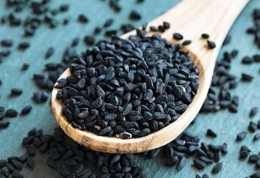
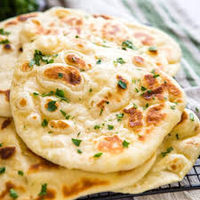
Nigella sativa is an annual flowering plant in the family Ranunculaceae, native to western Asia, and eastern Europe. It is naturalized over parts of Europe, northern Africa, and east to Myanmar. It is used as a spice in various food preparations, especially in Arab and Halal cuisines. Google
When cooking we are assessing the skills the students are using and mastering. The skills this recipe focusses upon are –
Transferring and embedding skills, knife skills (even sized chunks appropriate for cooking time, julienne, bridge, claw), using the oven correctly and safely, grating, preparing vegetables, handling dough, rolling, shaping and moulding, proving, yeast-based dough, quality and evenness, testing for readiness, following written instructions, washing and drying equipment, independence.

Naan – India
https://www.youtube.com/watch?v=MWI1bZ68e64 – Focaccia art
https://www.youtube.com/watch?v=NdTAcAgOONw – Shaping bread rolls https://www.wikihow.com/Knead-Dough - How to knead dough
Container /oven tray & Apron / Hair tie
No nuts or nut-based ingredients

- 1x 7g sachet dried yeast
- 2 tsp sugar
- 300g strong white bread flour plus extra for dusting
- ½ tsp baking powder
- 25g butter, melted, plus extra 2-3 tbsp for the tray and brushing
- 150ml natural yogurt
- Optional extras -
1 tbsp nigella seeds, coriander, chilli's

- Put 125ml warm water into a jug and sprinkle over the yeast and 1 tsp of the sugar. Leave for 5 mins or until frothy.
- Over a low heat - melt the butter and then leave to cool.
- In a large bowl, put the flour, remaining sugar, ½ tsp salt and baking powder.
- Mix together.
- Make a well in the centre - pour the melted butter, yogurt, nigella seeds / coriander / chilli's (if using) and yeast mixture.
- Stir well, then start to bring the mixture together with your hands.
- Knead the dough on a floured surface for at least 10 minutes or until smooth and elastic but still soft.
- Then shape the dough into a ball and place in the bowl. Cover and leave in a warm place for about 30mins – or as long as you have.
- Divide the dough into six balls and put them on a baking tray dusted with flour, then cover the tray with a damp tea towel.
- Heat a large non-stick frying pan over a medium heat.
- Take one of the balls of dough and roll it out to form a teardrop shape that’s approximately 21cm long and around 13cm at the widest part.
- Carefully lay the naan bread into the hot pan.
- Let it dry fry and puff up for about 3 mins, then turn over and cook on the other side for another 3-4 mins or until cooked through and charred in patches.

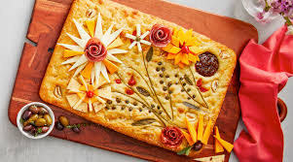
Focaccia is a type of Italian flatbread characterized by its olive oil-rich dough, dimpled surface, and crispy crust with a soft interior. It's known for its versatility and is enjoyed in various ways, from simple snacks to sandwich bread. The name "focaccia" is derived from the Latin "panis focacius," meaning "hearth bread," referring to its traditional preparation on the heart. Google
When cooking we are assessing the skills the students are using and mastering. The skills this recipe focusses upon are –
Transferring and embedding skills, knife skills (even sized chunks appropriate for cooking time, julienne, bridge, claw), using the oven correctly and safely, grating, preparing vegetables, handling dough, rolling, shaping and moulding, proving, yeast-based dough, quality and evenness, testing for readiness, following written instructions, washing and drying equipment, independence.

Focaccia – Italy
https://www.youtube.com/watch?v=MWI1bZ68e64 – Focaccia art
https://www.youtube.com/watch?v=NdTAcAgOONw – Shaping bread rolls https://www.wikihow.com/Knead-Dough - How to knead dough
No NUT or NUT based ingredients
APRON / Container / Hair Tie

- 500g strong bread flour plus extra for dusting
- 2 sachets of yeast
- 2 tsp salt
- 5 tbsp olive oil plus extra for the tin and to serve – try rape oil or sunflower as olive is expensive!
- Topping -
- 1/2 tsp salt
- ¼ small bunch of rosemary sprigs picked / dried herbs

- Preheat the oven to proving temperature – 50c.
- Tip the flour into a large mixing bowl.
- Mix the yeast into one side of the flour, and the salt into the other side.
- Mix everything together.
- Make a well in the middle of the flour and add 2 tbsp oil and 350-400ml lukewarm water, adding it gradually until you have a slightly sticky dough (you may not need all the water).
- Dust the work surface with flour and tip the dough onto it, scraping around the sides of the bowl.
- Knead for 10 mins until your dough is soft and less sticky.
- Oil a rectangular, shallow tin (25 x 35cm).
- Tip the dough onto the work surface, then stretch it to fill the tin.
- Cover with a tea towel and leave to prove in the oven or warm area for another 30 mins – if time allows for this.
- Turn up the oven to 200°C.
- Press your fingers into the dough to make dimples – docking the dough.
- Mix together 1½ tbsp olive oil and the salt, and drizzle over the bread.
- Push sprigs of rosemary into the dimples in the dough.
- Bake for 20 mins until golden.
- Whilst the bread is still hot, drizzle over the last 1-2 tbsp olive oil.

Breads of The World - 4
Fakewell Tart
https://www.youtube.com/watch?v=CTTmJhEhG-Y – 1.15 minutes, how to blind bake
Cake tin/dish & Apron / Hair Tie
No nuts or nut-based ingredients
1 packet pre-made shortcrust pastry
Filling;
- 2 – 3 tbsp. jam
- 100g butter
- 100g sugar
- 100g self raising flour
- 1 tsp baking powder – optional
- 2 eggs - beaten
- 1 tsp vanilla extract - optional
Optional - Substitute the jam for: curd, custard, fresh fruits,
canned fruits or even caramel.

Method
- Pre-heat the oven to 180°C.
- Roll out the pastry to fit the base and sides of your baking
tin.
- Lay into the bottom of the tin.
- Cover with tin foil / baking paper and weight down with rice/pasta/baking beans.
- Bake for 15–20 minutes – blind baking.
- Remove from the oven, remove the foil and rice and trim
the pastry so it is neat and tidy.
Filling –
- Mix together the butter and sugar until thick and
creamy.
- 1 tablespoon at a time add the beaten egg and stir, repeat
until all the egg has been added.
- Stir in the vanilla extract (optional)
- Fold in the flour and baking powder.
Assembling -
- Spoon the jam over the pastry and smooth over.
- Spoon over the cake mixture and even out using the
back of the spoon.
- Bake at 180°C – 200°C for 20 – 25 minutes.
- Optional extra – once cooled cover the top with lashings of water icing and finish with glace cherries.

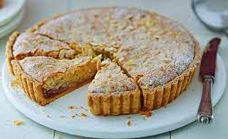
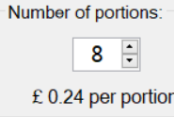
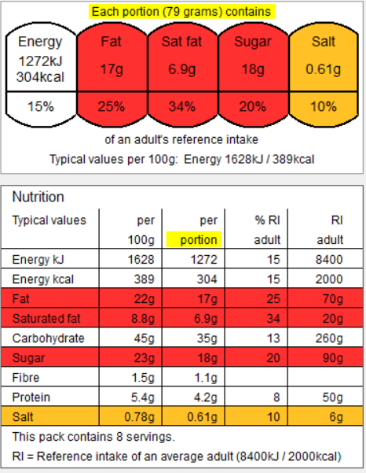
When cooking we are assessing the skills the students are using and mastering. The skills this recipe focusses upon are –

Weighing, measuring, rolling, shaping, lining, blind baking, pre-heating oven, testing for readiness, evenness, creaming, cracking, handling high risk ingredients, quality finish, following written instructions, washing and drying equipment, independence.

No Bake Lemon Cheesecake

https://www.youtube.com/watch?v=eZPJvobu35s – carnation 43s

This dessert is to be eaten as a part of a balanced diet, as you can see by the ingredients they are not a healthy option, but there are always ways to make foods healthier to eat.
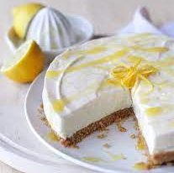

Cake tin / quiche dish & Apron / Hair Tie
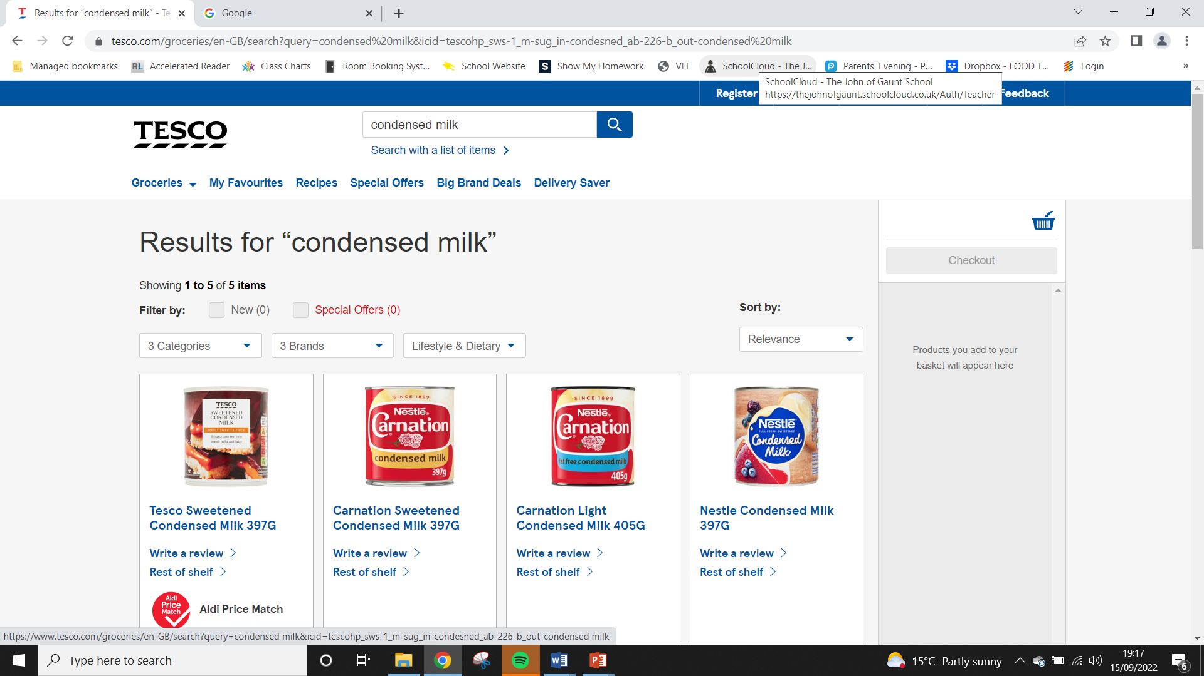
No nuts or nut-based ingredients
200g digestive biscuits
70g butter
½ can condensed milk
3oog full fat cream cheese – (buy the cheaper brand!!)
2 lemons, juiced
Optional extra – 3 / 4 tbsp lemon curd

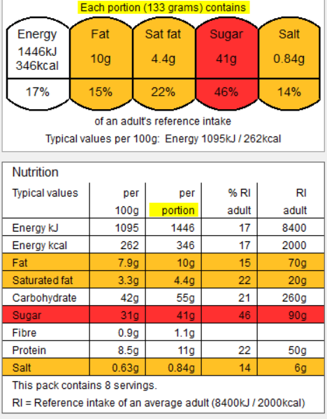
You could change the lemon for – lime, orange or forest fruits

Method -

Make the cheesecake base:
- Melt the butter in a small pan over a medium heat.
- Put your biscuits into your own dish. Using the end of the rolling pin, crush the biscuits to a fine crumb.
- Add the melted butter and stir until well combined.
- Press down firmly into the base.
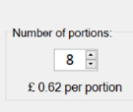
- Place into the fridge to chill until needed.
Make the filling
- Zest the lemon and set to one side.
- Cut the lemon in half and juice, pour the juice into a
When cooking we are assessing the skills the students are using and mastering. The skills this recipe focusses upon are –

Weighing, measuring, melting, crushing, mixing, layering, pressing, even shaping, slicing, zesting, juicing, using the hob correctly and safely, testing for readiness, evenness, quality finish, following written instructions, washing and drying equipment, independence.

large bowl.
- Add the condensed milk, lemon curd, lemon and zest
and cream cheese to the juice and mix.
- Smear over the top of the biscuit base and chill for at
least 2hrs to set.

Never assume a pan handle or oven tray is cold!
You cannot tell by looking at it!


Minestrone Soup – No Food Waste
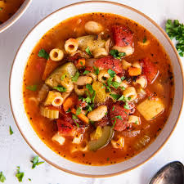
https://www.youtube.com/watch?v=2bQdqBq8Ac8 - Minestrone soup
Container with a lid & Apron / Hair Tie
No nuts or nut-based ingredients

- 3 tbsp oil
- 1 onion
- 1 celery stick
- 1 carrot
- 2 rashers of bacon / veggie bacon
- 1 garlic clove, crushed
- 1 tin cannellini or haricot beans
- 1 tin chopped tomatoes
- 1 vegetable stock cube
- 70g small pasta like macaroni
- 100g greens - kale, chard, cabbage or Cavolo Nero work well
Optional extra - -peppers, courgette, mushroom, sweetcorn, etc.

Method –
- Prepare all ingredients – open cans, finely chop vegetables, crush garlic and chop, chiffonade of cabbage, slice bacon into jardinière, etc.
- Heat the oil in a large saucepan over a low-medium heat and gently fry the onion, celery, carrot, and garlic (and any other vegetables you may have) for 8/10 mins.
- Tip in the beans, chopped tomatoes, purée and stock.
- Bring to the simmer and cook for 20 mins.
- Fry your bacon in a separate frying pan, (you may need to share a frying pan at this point).
- Remove 2 large ladles full of the soup into a measuring jug. Blitz with the stick blender.
- Put back into your soup.
- Add the pasta and greens, and cook for a further 10 mins.

Never assume a pan handle or oven tray is cold!
You cannot tell by looking at it!

When cooking we are assessing the skills the students are using and mastering. The skills this recipe focusses upon are –
Transferring and embedding skills, simmering, knife skills (even sized chunks appropriate for cooking time, bridge, claw, chiffonade, macedoine), how to prepare vegetables, using the hob correctly and safely, handling and cooking high risk ingredients, testing for readiness, Maillard reaction, frying, boiling, simmering, testing for readiness, following written instructions, seasoning, washing and drying equipment. independence.

FOOD WASTE FACTS
1) Around 1.3 billion tonnes of food is wasted every year - National Geographic, 2015
2) If food waste were a country, it would be the third-largest greenhouse gas emitter, after China and the US - Stop Wasting Food Movement, 2020
3) An area larger than China is used to grow food that's never eaten - Fao, 2013
4) UK farmers are forced to throw away 10-16% of their crop annually because of foods supermarkets have considered simply 'ugly' or misshapen - Feedback, 2018
5) 45% of all the fruits and vegetables produced globally are wasted - Fao, 2015
8) The food wasted in Europe could feed 200 million people. Latin America and Africa could both feed 300 million people with their food waste - Earth.org, 2020


https://www.youtube.com/watch?v=1ovZkhTAy_Y –
Waitrose, Traditional Shortbread.

Container & Apron / Hair Tie
No nuts or nut-based ingredients
- 65g butter or margarine
- 30g caster sugar, plus extra to sprinkle
- 100g plain flour

Method –
- Put the butter and sugar in the bowl and cream together using a wooden spoon.
- Add the flour and mix though.
Tip out the mixture onto a work surface and gently bring it together, then knead it into a dough.
- Once the dough is formed, wrap it in cling film and chill for 10 minutes.
- Preheat the oven to 180°C.
- Lightly flour the work surface and roll out the dough until it is about 3mm thick (about the thickness of a £1 coin).
- Use the 6cm fluted cutter to stamp out 8/10 biscuits, re-rolling the trimmings as necessary.
- Place the biscuits on the lined baking sheet and chill for another 5 minutes, then use a fork to prick a few lines of holes (dock) in the centre of each.
- Sprinkle the biscuits with a little caster sugar and bake for 10–12 minutes, or until lightly golden.

Shortbread – Quality & Precision

When cooking we are assessing the skills the students are using and mastering. The skills this recipe focusses upon are –
Embedding and transferring skills, weighing, measuring, adding, mixing, even shaping, use of a rolling pin, use of pastry cutters, checking for consistency and readiness, creaming method, baking, using the oven correctly and safely, following written instructions, washing and drying equipment, independence.

History
Shortbread originated in Scotland. Shortbread is derived from a medieval biscuit bread, which was a twice-baked, enriched bread roll dusted with sugar and spices and hardened into a hard, dry, sweetened biscuit called a rusk. Eventually, yeast from the original rusk recipe was replaced by butter, which was becoming more of a staple in Britain and Ireland.
https://grannyfis.com/our-story
Never assume a pan handle or oven tray is cold! You cannot tell by looking at it!
Bad Boy Burritos
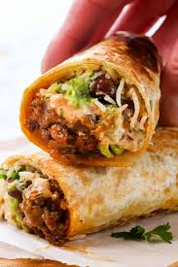
https://www.youtube.com/watch?v=sY7ZcIS6Njk – Chicken Burritos
Container with a lid & Apron / Hair Tie
No nuts or nut-based ingredients
- 4 skinless, boneless chicken thighs/2 chicken breast/tofu /TVP /minced beef or chicken
- Packet of fajita / burrito mix
- 4 tbsp olive oil
- 1 onion
- 1 red pepper - optional
- 1/2 tin of pinto/black/kidney beans (refried beans are also good!)
- 50g cooked rice
- 4 large flour tortillas
Optional extras – lettuce, lime, can of tomatoes

Method –
- Prepare all ingredients – julienne the peppers and onions, open cans, etc.
- Slice the chicken into jardinière strips.
- Fry vegetables, meat and spices in the oil until vegetables are softened and chicken is cooked all the way through - 8/10 minutes.
- Drain the water from the beans and add to the pan.
- If using canned tomatoes - add these and stir.
- Assemble your burrito. Place rice evenly between the 4 tortillas, top with chicken fajita mixture and any extra ingredients (lettuce etc). Wrap in foil or place into your container.

The main principles of healthy eating are:
- including plenty of fruit and vegetables – at least 5 A DAY
- including plenty of fibre-rich foods, especially wholegrains
- including a range of protein-sources, especially beans, peas and lentils
- including some dairy foods or fortified alternatives
- choosing mainly unsaturated fats and oils, and
- minimising foods and drinks that are high in fat, salt and sugars.
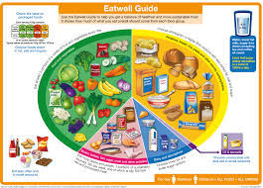

When cooking we are assessing the skills the students are using and mastering. The skills this recipe focusses upon are –
Transferring and embedding skills, knife skills (even sized chunks appropriate for cooking time, bridge, claw, julienne & jardinière), how to prepare vegetables, using the hob correctly and safely, handling and cooking high risk ingredients, testing for readiness, Maillard reaction, frying, boiling, filling & rolling, testing for readiness, following written instructions, seasoning, washing and drying equipment. independence.

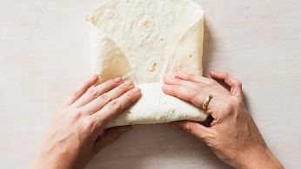
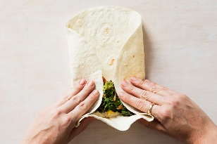
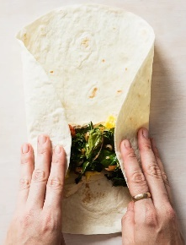
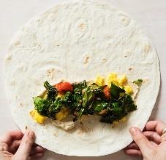

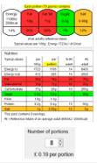
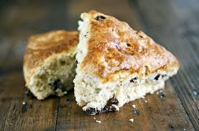

When cooking we are assessing the skills the students are using and mastering. The skills this recipe focusses upon are –

Weighing, measuring, using electric whisk, mixing, shaping and moulding dough, rubbing in, resting, squeezing, even shaping, glazing, using the oven correctly and safely, testing for readiness, quality finish, following written instructions, washing and drying equipment, independence.

A little bit of science –
The baking powder will produce carbon dioxide gas to raise the scones.
https://www.youtube.com/watch?v=e1LYWF8T8g0 – How to make butter – SciShow Kids
Container & Apron / Hair Tie
No nuts or nut-based ingredients

- 250g self-raising flour (or ½ wholemeal & ½ self-raising to increase fibre)
- 1 small tub of double cream (250ml) to make the butter & buttermilk
- 50-80g butter – made from the cream!
- 100ml buttermilk – made from the cream!
- 1 tsp baking powder
- 100g grated cheese (or low-fat cheese / use less to reduce the saturated fat)
Let’s make butter and buttermilk
- Pour the double cream into a large bowl.
- Using an electric or hand whisk, whisk the cream until it separates into solids and liquid.
- Continue until the solids thicken – this is your butter!
- Squeeze out the excess buttermilk.
- Pour the liquid – buttermilk, into your measuring jug.
- Chill your butter before using OR chill your scones before cooking.
To make the scones –
- Preheat the oven to 180°C.
- Line a baking tray.
- Using your fingertips rub the butter into the flour until it resembles fine breadcrumbs.
- Add the baking powder
- Add your flavourings if using.
- Pour in the buttermilk a tablespoon at a time and mix to form a soft dough. Save a little of the buttermilk.
- Place the dough on a floured surface.
- Pat out the dough until 1.5cm thick.
- Shape into petticoat tails.
- Place the scones onto the baking
tray, brush the tops with a little
buttermilk and bake for 12-15
minutes until golden brown.
- After baking, place the scones
on a cooling rack.
Never assume a pan handle or oven tray is cold! You cannot tell by looking at it!

Buttermilk Scones
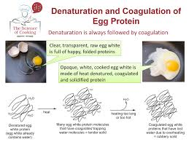
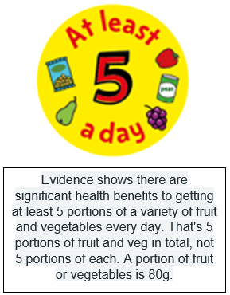
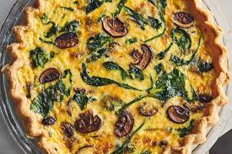
https://www.youtube.com/watch?v=tA_LY3hO5wM – Lorraine Pascal Mini Quiche using filo pastry
Container with a lid, Apron / Hair Tie
No nuts or nuts-based ingredients
- Oven dish from home – Victoria cake tin.

- 1 packet shortcrust pastry

Filling -
- 100-150g cheese – grated
- 4 eggs
- 150ml milk/double cream

Optional extras –
- 50g bacon or any other cooked meat, 50g smoked salmon / tuna / crab, ½ onion, ½ pepper, ½ courgette, ¼ tin sweetcorn, 1 tomato, asparagus, herbs (chives, parsley, thyme, basil, rosemary, etc)

Method –

- Preheat the oven to 190°C.
- Roll out the pastry on a light floured surface and line your oven dish. Don't cut off the edges of the pastry yet, the pastry will shrink due to the protein retracting back.
- Cover the pastry case with foil and add a small handful of baking beans on the top.
- Place on a baking tray and bake blind for 15 minutes.
- Remove the beans and foil. Trim off excess pastry.
- Reduce the temperature of the oven to 160°C.
- Sprinkle the cheese into the pastry base and add your other flavourings.
- Combine the eggs with the milk / cream in a jug and pour over the pastry.
- Bake for 20 minutes or until set. Remove from the oven.

When cooking we are assessing the skills the students are using and mastering. The skills this recipe focusses upon are –
Weighing, measuring, rolling, shaping, lining, blind baking, pre-heating oven, testing for readiness, evenness, mixing, trimming, knife skills to prepare vegetables (bridge, claw, macedoine, brunoise, julienne) cracking, handling high risk ingredients, quality finish, following written instructions, washing and drying equipment, independence.

Quiche – Could you go Veggie?
Shortbread

