
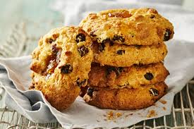
A little bit of Science –
https://www.youtube.com/watch?v=1dmv1q00IJU – 1.56 minutes

When designing your rock cakes, try to think about the healthy eating guidelines - can you include any of these healthy eating options listed in the recipe below?

Container with a lid & Apron / Hair Tie
No nuts or nut-based ingredients

225g self-raising flour (for higher fibre use ½ wholemeal & ½ SR flour)
75g sugar
1 tsp baking powder
125g margarine or butter (to lower the saturated fat you could try low fat polyunsaturated margarine)
100g dried fruit
1 egg
1 tbsp milk
1 tsp vanilla extract – optional

Method -
- Preheat oven to 180°C, line a baking tray with foil.
- Rub together the butter and flour until it looks like breadcrumbs.
- Mix in the dried fruit, sugar and baking powder.
- Crack in the egg and add the vanilla.
- Stir with a spoon until the mixture just comes together as a thick, lumpy dough.
- Add a teaspoon of milk if you really need it to make the mixture stick together.
- Place golf ball-sized spoons of the mixture onto the prepared baking tray.
- Leave space between them as they will flatten and spread out.
- Bake for 15-20 minutes, until golden-brown.
- Remove from the oven, allow to cool.

Never assume a pan handle or oven tray is cold! You cannot tell by looking at it!

Fruity Rock Cakes
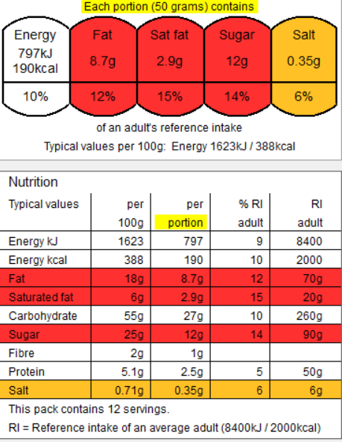
When cooking we are assessing the skills the students are using and mastering. The skills this recipe focusses upon are –

Weighing, measuring, adding liquids in a controlled manner, correctly & safely handling high risk ingredients, mixing, even shaping, rubbing in, baking, using the oven correctly and safely, testing for readiness, following written instructions, washing and drying equipment, independence.

A little bit of science –
The baking powder will produce carbon dioxide gas to raise the cakes.
‘Short’ means to crumble – these cakes are short because the rubbing in process prevents the protein in the flour from absorbing too much liquid.
Eggs will coagulate to set the cakes.

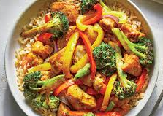
https://www.youtube.com/watch?v=wsvfA0YOLUs – chickpea and spinach curry, Food with Chetna
Container with a lid & Apron / Hair Tie
No nuts or nuts-based ingredients

- 250g chicken/pork/turkey /Quorn/butternut squash
- 1 onion
- 1-2 cloves of garlic
- 1 large tin of chopped tomatoes (400g)
- 2-3 teaspoons curry powder / paste
- 100ml coconut milk or cream- low fat is good, as these are all saturated fats! You could try a vegan version?
- 1 tbsp oil
- Additional ingredients: You may want to add other vegetables to the curry, e.g. peppers, mushrooms, cauliflower, spinach, chickpeas, lentils, courgette, pumpkin, aubergine, etc.
- You could change to a Thai curry / jungle curry, Katsu curry and substitute the tomatoes for ½ can of coconut milk.

- Peel and chop the onion.
- Peel and crush the garlic.
- Prepare any additional vegetables used and place onto a tray / bowl.
- Chop the chicken into bite size chunks.
- Place the chicken into the saucepan with the oil, and fry for 5 minutes on a low heat.
- Add the onion (plus any additional vegetables) and garlic, and fry for 5 minutes.
- Add the tinned tomatoes and curry paste / powder (coconut milk if using). Allow to simmer for 10-15 minutes, stir regularly.
- If adding cream, remove the curry from the heat and allow to cool slightly before stirring through.

Chicken & Vegetable Curry
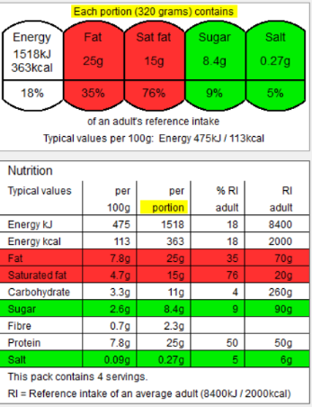
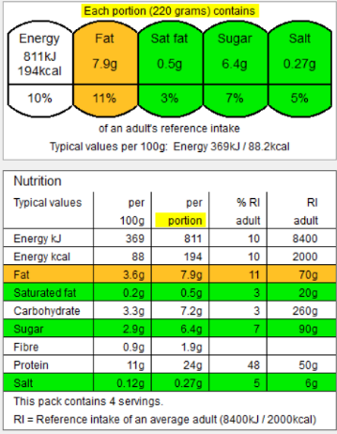
With whole coconut milk
Please take note – the saturated fat has increased dramatically this is because coconut milk is a source of saturates.

Without coconut milk
Image from Google images
When cooking we are assessing the skills the students are using and mastering. The skills this recipe focusses upon are –
Transferring and embedding skills, simmering, knife skills (even sized chunks appropriate for cooking time, bridge, claw), how to prepare an onion, using the hob correctly and safely, handling and cooking high risk ingredients, testing for readiness, Maillard reaction, following written instructions, seasoning, washing and drying equipment, independence.

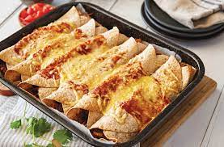
The main principles of healthy eating are:
- 1. Including plenty of a range of fruit and vegetables – at least 5 A DAY
- 2. Including plenty of fibre-rich foods, especially wholegrains
- 3. Including a range of protein-sources especially beans, peas and lentils
- 4. Including some dairy foods or fortified alternatives
- 5. Choosing mainly unsaturated fats and oils, and
- 6. Minimising foods and drinks that are high in fat, salt and sugars.

When cooking we are assessing the skills the students are using and mastering. The skills this recipe focusses upon are –
Transferring and embedding skills, simmering, knife skills (even sizes – fine brunoise, julienne, bridge, claw), how to prepare an onion, using the hob correctly and safely, handling and cooking high risk ingredients, reduction sauce, testing for readiness, Maillard reaction, following written instructions, seasoning, washing and drying equipment, independence.

Image from Google images
https://www.youtube.com/watch?v=jRlTxTNRo1s – Preppy Kitchen 8.39 minutes

Oven dish/ cake tin & Apron / Hair Tie
No nut or nut-based ingredients

- leftover roast chicken meat, chopped or shredded OR 1 raw chicken breast.
- 1 pack tortilla wraps – try wholemeal to increase fibre
- 1/2 can red kidney beans OR mixed beans in chilli sauce.
- 1 carton tomato passata / canned tomatoes
- 1 packet fajita seasoning
- 1 onion
- 50g / 100g cheddar, grated
- 2tbsp oil
Optional extras (keep it to a minimum we have 40mins to cook) – pepper, garlic, courgette, mushrooms, sweetcorn.

Prepare the vegetables:
- Peel and slice the onions into julienne, along with peppers, courgette if using. Peel and crush the garlic. Slice the mushrooms.
Prepare the meat –
- Slice the chicken into julienne strips.
- Thoroughly wash and dry your hands after touching the raw meat.
For the enchilada sauce.
- Add the oil to the saucepan and gently fry the chicken and onion for 5 minutes.
- Add the remainder of the vegetables and continue to cook for a further 5 minutes.
- Add the fajita seasoning and stir through.
- Add the chopped tomatoes / passata and kidney beans.
- Bring up to the boil and then reduce down to a simmer and cook for 15 minutes.
- Lay out a tortilla, half fill one side and roll up (think a wrap).
- Place into your oven dish, repeat until your ingredients are used.
- Sprinkle the top with cheese.
At Home -
- Bake in a preheated oven at 190°C/170°C fan for 25 minutes, or until it is piping hot all the way through and serve with coriander and salad. Top Tip – to stop the tops from drying out or burning – cover the top with tin foil!
- You can also pop them into the microwave.

Enchiladas
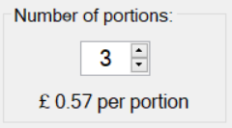
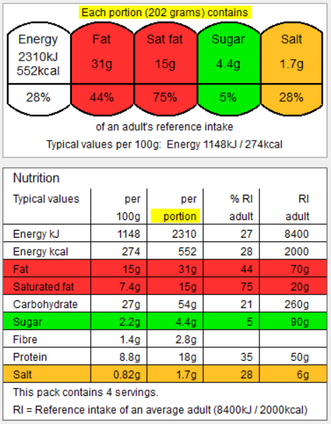
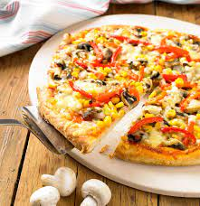
https://www.youtube.com/watch?v=Ur-z6slS36U – 5.59 minutes
Today we will be using white flour, you could switch to wholemeal flour to increase the fibre content. Fibre is known to help lower blood cholesterol.
Container / plate with tin foil & Apron / Hair Tie
No nut or nut-based ingredients

For the Base –

- 250g self-raising flour – you could use wholemeal flour to increase fibre
- 75g margarine/butter
- ¼ pint milk – you may need a splash extra.
- 2tsp baking powder

For the Topping –

- 3tbsp. sauce – pasta sauce, BBQ, tomato puree, etc.
- 150g cheese

Toppings of your own choice – try to add at least 2 different vegetables. When choosing meat, look for lean and low fat.

- Turn the oven on to 200°C.
Make the base –
- Put the flour into a large bowl and add the margarine rub together with the tips of your fingers.
- Stir in the baking powder. Add the milk 1 tablespoon at a time and stir until you have a firm dough.
- Press out or roll into a round shape - the thinner the base, the crispier it will be.
- Place onto a floured baking tray.

The topping –
- Spread the sauce over the base but leave 2cm between the edge of the base and the sauce
- Spread the cheese on top.
- Place the topping of your choice on top of the cheese.
- Bake in the oven at 200°C for 15 to 20 minutes.
When cooking we are assessing the skills the students are using and mastering. The skills this recipe focusses upon are –

Transferring and embedding skills, simmering, rubbing in, knife skills (brunoise, julienne, chiffonade, bridge, claw), adding liquids in a controlled manner, mixing, rolling, shaping dough, layering, using the oven correctly and safely, testing for readiness, following written instructions, washing and drying equipment, independence.

Image from Google images
Scone Based Pizza

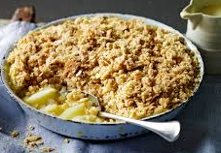
https://www.youtube.com/watch?v=a-dCICl6GeE - Jamie Oliver 5.28 minutes
We will be using eating apples not Bramley apples as eating apples are naturally sweeter, so there is less need to add sugar, making this a healthier option.
Oven dish/ cake tin & Apron / Hair Tie
No nut or nut-based ingredients
Crumble topping –
- 125g plain flour (to increase fibre you can use ½ plain & ½ whole meal flour)
- 75g sugar
- 50g margarine/butter
Optional extras – 20g oats or other high fibre cereal, 1tsp cinnamon / ginger
Fruit filling -
- 350g apples
- 350g pears
- 50g sugar
- 25g margarine/butter
Optional extras – 30g dried fruits, berries.

To make the crumble topping –
- Sift the flour into a large bowl.
- Rub in the margarine (50g) using the tips of your fingers until the mixture looks like breadcrumbs.
- Add the sugar, and any other topping ingredients and mix. Set to one side.
To make the fruit filling -
- Peel the apples and pears, quarter them and take out the core.
- Cut the fruit into chunks (practice your knife skills) and place into the saucepan.
- Add the butter and sugar and cook over a low heat until tender.
- Transfer the fruit to an oven proof dish and cover with the crumble.
At home - Bake at 200°C for 25 minutes or until piping hot.

Fruit Crumble
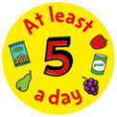
When cooking we are assessing the skills the students are using and mastering. The skills this recipe focusses upon are –

Transferring and embedding skills, simmering, rubbing in, knife skills (brunoise, macedoine, julienne, jardinière, bridge, claw) draining, layering, using the hob and oven correctly and safely, testing for readiness, following written instructions, washing and drying equipment, independence.

Evidence shows there are significant health benefits to getting at least 5 portions of a variety of fruit and vegetables every day. That's 5 portions of fruit and veg in total, not 5 portions of each. A portion of fruit or vegetables is 80g.
Image from Google images
Macaroni Cheese / Vegetable Bake
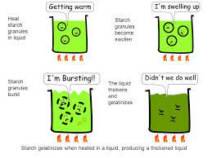
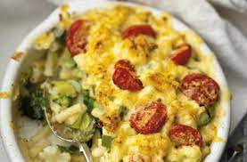
When cooking we are assessing the skills the students are using and mastering. The skills this recipe focusses upon are –
Boiling, draining, making a bechamel sauce (gelatinisation), roux, grating, using the hob correctly and safely, mixing, knife skills if using vegetables – florets, jardinière, julienne, testing for readiness, following written instructions, washing and drying equipment, independence.

https://www.youtube.com/watch?v=9aeCJGmEXqE – Gordon Ramsey – 2.10 minutes

Container with a lid / oven dish & Apron / Hair Tie
No nuts or nut-based ingredients.
- 250g pasta (wholemeal will increase the fibre) or cauliflower / broccoli
- 40g butter (to lower the saturated fat you could try polyunsaturated margarine)
- 40g plain flour
- 1 pint milk – semi skimmed is good
- 250g grated cheddar (you could try low fat or low salt cheese)
- Optional extras - think – can I add at least 1 vegetable?
50g grated parmesan, sweetcorn, peas, carrots, cooked bacon, ham, tuna.

1. Cook the pasta / vegetables in a large saucepan of boiling water for 10 - 15 minutes; drain well and set aside. You want them to begin to go soft – remember they will cook again in the oven!
2. Melt the butter over a medium heat in a saucepan.
3. Add the flour and stir to form a roux - cook for 2 minutes.
4. Gradually whisk in the milk, a little at a time.
5. Cook for 10-15 minutes to a thickened and smooth sauce.
6. Remove the sauce from the hob, add ¾ of the cheese and stir until the cheese is well combined and melted.
6. Add the pasta / vegetables to the sauce and mix well. Transfer to a deep suitably-sized ovenproof dish.
7. Sprinkle over the remaining cheese.
At home – Bake at 180 °C for 20 -30 minutes or until piping hot.

A little bit of science –
When starch is mixed with water and heated, the starch granules swell and eventually rupture, absorbing liquid, which thickens the mixture -this is gelatinisation.
On cooling, if enough starch is used, a gel forms. This process is used in the production of blancmange.

Image from Google images
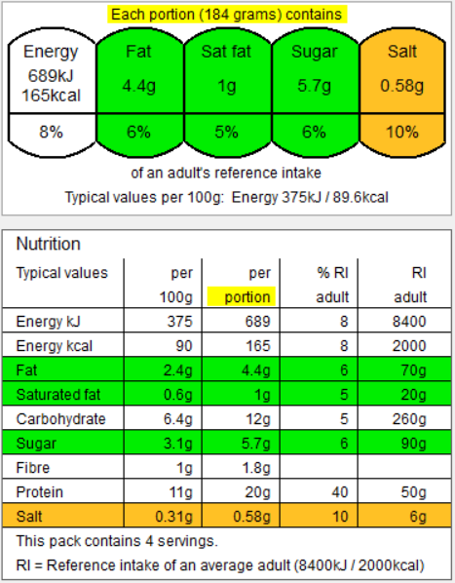
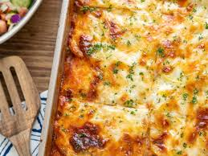
When cooking we are assessing the skills the students are using and mastering. The skills this recipe focusses upon are –
Transferring and embedding skills, simmering, knife skills (even sizes – fine brunoise, jardinière, bridge, claw), how to prepare an onion, using the hob correctly and safely, handling and cooking high risk ingredients, reduction sauce, testing for readiness, Maillard reaction, using the food processor, following written instructions, seasoning, washing and drying equipment. independence.

Image from Google images

Oven dish with tin foil / cling film & Apron / Hair Tie
No nuts or nut-based ingredients.

- 1 jar passata/tomato pasta sauce/tinned tomatoes
- 3 tbsps double cream/crème fraiche / mascarpone/ creamed cheese.
- 2 chicken breast / turkey meat / Quorn
- 1 pepper
- 2 slices of stale bread for breadcrumbs – wholemeal is good for fibre – optional.
- 1 tbsp oil
- Grated cheese for topping - optional

Optional extras – (remember you only have 40 minutes) – sweetcorn, courgette, mushrooms)

Breadcrumbs –
- Put the bread into a food processor and blend until you have rough crumbs.

Filling –
- Prepare the vegetables – slice into jardinière.
- Prepare the meat – slice into jardinière.
- In the saucepan add the oil and meat and cook for 5 minutes.
- Add the vegetables and cook for a further 10 minutes.
Sauce –
- Pour into your oven dish / container.
- Mix the tomato passata or tinned tomatoes with the double cream / creme fraiche / mascarpone / creamed cheese.
- Pour over the creamy passata, top with breadcrumb and cheese if using.

At home - Bake in the oven at 200°C, until the meat is piping hot and the breadcrumbs are crisp and brown.

Chicken and Vegetable Gratin
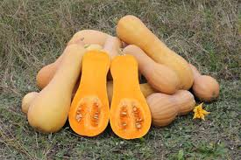
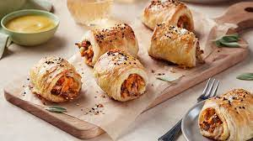
Image from Google images
Butternut squash is a popular winter squash variety, known for its sweet, nutty flavour and smooth, tan skin. It's a good source of vitamins A and C, potassium, and fibre, offering various health benefits. Butternut squash is versatile in the kitchen, suitable for roasting, soups, stews, and other dishes. Google
https://www.youtube.com/watch?v=uoMR-Zz0q0c – Chetna veggie sausage rolls – 5.02 minutes
Container with a lid & Apron / Hair Tie
No nuts or nuts-based ingredients
- 1 packet of puff pastry
- 1 egg
- ½ butternut squash
- 1 onion
- 2 slices of stale bread
- 1-2 cloves of garlic
- Rosemary – to taste (not too much as it is strong)
- Few chilli flakes to taste

When cooking we are assessing the skills the students are using and mastering. The skills this recipe focusses upon are –
Transferring and embedding skills, knife skills (even sized chunks appropriate for cooking time, bridge, claw), how to prepare an onion, using the oven correctly and safely, preparing vegetables, roasting, scooping, blending, using a food processor, handling pastry, rolling, glazing, sealing, shaping and moulding, quality and evenness, testing for readiness, dextrinization, following written instructions, washing and drying equipment, independence.

- Preheat oven to 200°C.
Filling -
- Slice the butternut squash in half and remove the seeds.
- Place onto a baking tray and bake until soft (20-30 minutes).
- Meanwhile peel and finely chop the onion. Fry in a saucepan until tender.
- Finely chop the garlic and rosemary. Add to the onion, along with the chilli flakes and cook for a further 2 minutes.
- Take the squash put of the oven and allow to cool slightly.
- Scoop the flesh out of the butternut squash and add to the onion mixture.
- Grate the stale bread to make breadcrumbs and add to the mixture along with the egg.
Pastry -
- Roll out the pastry and slice into 2 rectangles.
- Put a sausage shaped layer of mixture along the length of the pastry.

- Brush the bottom edge with water or beaten egg.
- Fold the top of the pastry over to meet the bottom and seal using a fork.
- Slice into even sized shapes and place onto a baking tray.
- Brush the tops with beaten egg or milk and bake at 200°C for 15-20 minutes.

Butternut Squash Sausage Rolls
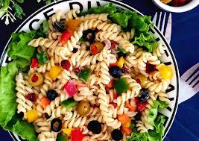
https://www.bbcgoodfood.com/recipes/layered -rainbow-salad-pots
Thinking about the Eatwell Guide we will be designing and making a Rainbow salad.
Container with a lid & Apron / Hair Tie
No nuts or nut-based ingredients.

Carbohydrate –
- 250g pasta / rice / potato/ couscous / noodles – raw (not cooked)
Vegetables / Fruit -
- 3 different vegetables, e.g. carrot, pepper, onion, spring onion, cucumber, olives, tomato, beetroot, lettuce, sweetcorn, etc.
Protein -
- Cooked - chicken, ham, beef, bacon, low fat sausage, chorizo, egg, tuna, salmon, Quorn, tofu, peas, beans, lentils, chickpeas. – cooked!
Dairy –
- Cheese – blue, camembert, brie, cheddar, smoked, mozzarella, goats.
- Natural / Greek yoghurt (to make a dressing)
Optional -
- Your own choice of dressing, e.g. low-fat mayonnaise, salad cream, Caesar salad dressing, ranch, salsa, guacamole, etc.
- You can make your own.
- Herbs – basil, chives, coriander, parsley

- Half fill a saucepan with cold water, place it on the hob and switch on to a medium/high heat.
- Heat the water until it is boiling.
- Add pasta (potato / rice / noodles) and cook as label directs (until it feels soft). For the cous cous – read and follow the instructions on the back of the packet.
- Drain the pasta using a colander in the sink.
- Cool the pasta down by running cold water from the tap over it.
- Pour the pasta into your container.
- Peel / chop / slice / grate all other ingredients – remember to use the Bridge and Claw techniques.
- Add the prepared ingredients to the pasta and stir through or make layers.
- Add your dressing and stir through.
- Refrigerate.
Never assume a pan handle is cold!
You cannot tell by looking at it!

Rainbow Salad
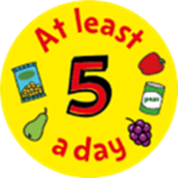

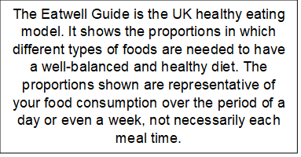
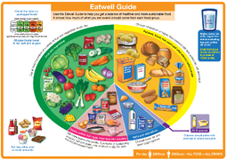
When cooking we are assessing the skills the students are using and mastering. The skills this recipe focusses upon are –

Knife skills – brunoise, macedoine, julienne, jardinière, bridge and claw, boiling, draining, using the hob correctly and safely, boiling, simmering, testing for readiness, tasting for seasoning, following written instructions, washing and drying equipment, independence.

Image from Google images
v
Container with a lid & Apron / Hair Tie
No nuts or nuts-based ingredients

- 1 packet of puff pastry
- 1 packet of sausages or sausage meat (reduced fat is a good low-fat alternative)
- Optional extras – egg (to glaze) cheese, bacon, herbs, apple, pear, sundried tomato, chutney, pickle, etc.
Preheat the oven to 200°C/Gas 6.
Prepare sausage meat –
- Skin sausages, place into bowl, prepare other flavours and mix through – split into 3 equal chunks.
Shaping
2. Shake flour onto the table and rolling pin.
3. Unroll/roll out the pastry out into a large rectangle, then cut into 3 long rectangles.
Assembling
4. Place a sausage-shaped layer of sausage meat mixture down the middle of each pastry rectangle, then brush water onto one edge.
5. Fold the other side of the pastry over onto the watered edge. Press down to seal and trim any excess. Cut each pastry roll into even sized sausage rolls.
6. Place the sausage rolls onto a baking tray and transfer to the oven to bake for 15-20 minutes, or until crisp and golden and the sausage meat is completely cooked through – 75°C for 30 seconds!
For larger sausage rolls please allow extra cooking time
When cooking we are assessing the skills the students are using and mastering. The skills this recipe focusses upon are –
Transferring and embedding skills, knife skills (even sized chunks appropriate for cooking time, bridge, claw), how to prepare an onion, using the oven correctly and safely, preparing vegetables, roasting, scooping, blending, using a food processor, handling pastry, rolling, glazing, sealing, shaping and moulding, quality and evenness, testing for readiness, dextrinization, following written instructions, washing and drying equipment, independence.

Sausage Rolls
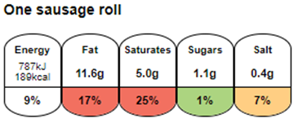
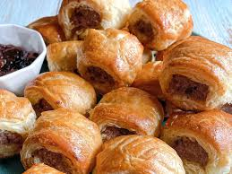
Sausage rolls, a popular savoury pastry snack, have a long history, with roots in ancient times. While the modern sausage roll is thought to have originated in France during the 19th century, they became a common British street food in the early 1800s. They are now a widely enjoyed snack in the UK and other Commonwealth nations. Google
Image from Google images
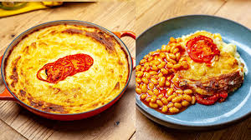
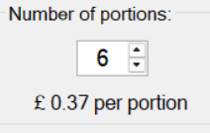
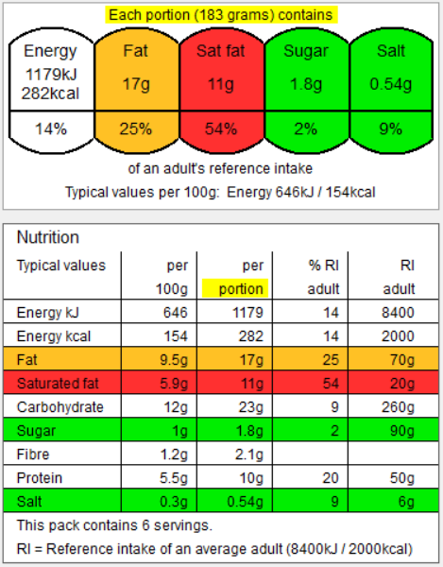
https://www.youtube.com/watch?v=v8IGsE2Oug8 - Makewell with Miss markwell
Oven Dish with cling film / tin foil & Apron / Hair Tie
No nuts or nuts-based ingredients

- 750g potatoes
- 50g butter
- 150ml. milk
- 175g cheese
Optional extras –
- 2 slices ham
- 3 slices cooked bacon
- 1tbsp mayonnaise / creamed cheese
- 1 tomato
When cooking we are assessing the skills the students are using and mastering. The skills this recipe focusses upon are –
Transferring and embedding skills, knife skills (even sized chunks appropriate for cooking time, bridge, claw), how to prepare various ingredients, using the hob correctly and safely, mashing, mixing, spreading, layering, draining, quality and evenness, following written instructions, washing and drying equipment, independence.

- Peel the potatoes and cut into even sized pieces.
- Put the potatoes into a saucepan and cover with cold water.
- Put onto the hob and bring to the boil. Simmer for about 20 minutes until soft.
- Slice the tomato / ham / bacon.
- Using a colander, drain the potatoes.
- Mash the potatoes with the milk, butter and half of the cheese. If using mayonnaise / creamed cheese – add this as well.
- Put into an oven proof dish.
- Place sliced tomato / ham / bacon on the top.
- Sprinkle with the rest of the cheese.
At home - Bake in the oven for 20 minutes, or until golden.
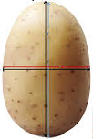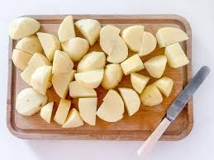
Image from Google images
Cheese & Potato Bake

