
Meatballs

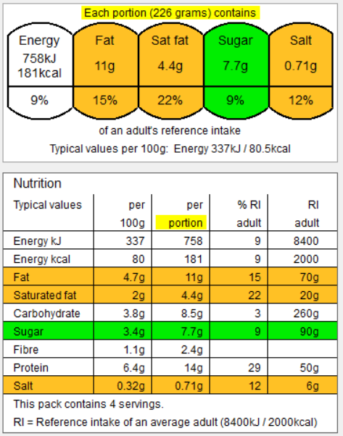
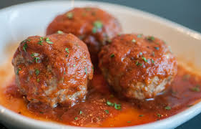
https://www.youtube.com/watch?v=FWWHtN6wDvw – 8.42 minutes Jamie Oliver meatballs

Container with a lid & Apron / Hair Tie
No nuts or nut-based ingredients.
1 packet minced meat / Quorn / falafel mix– beef, pork, chicken.
1 onion – optional
1 carrot – optional
1 can tomatoes
2-3 tablespoon tomato puree
Basil – fresh or dried

Optional extras:
- Meatballs – garlic, chilli, rosemary, rhyme, paprika, onion, cheese, chutney.
- Tomato Sauce – celery, courgette, mushroom, peppers, olives, herbs, spices, pumpkin, sweetcorn, etc.
Meatballs
- Preheat the oven to 180°C
- Chop all meatballs flavours / vegetables as small as possible – BRUNOISE.
- Put the meat into the bowl, add any other flavours / ingredients that you are using.
- Using your hands mix together and then form into small balls.
- Place onto a baking tray and bake at 180°C for 20 minutes.
Tomato sauce
- Chop / peel / slice all vegetables.
- Add a few drops of water to the large saucepan and fry the vegetables until soft (10 – 15 minutes). Keep adding water if the vegetables stick.
- Add the tinned tomato, herbs / spices and stir through.
- Pour in half a can of water and stir through.
- Cook on a low heat for as long as possible OR at least 15 minutes.

To assemble
- Pour the sauce into your container and dot the meatballs over the top.
Never assume a pan handle or oven tray is cold! You cannot tell by looking at it!

When cooking we are assessing the skills the students are using and mastering. The skills this recipe focusses upon are –

Transferring and embedding skills, simmering, knife skills (brunoise, jardinière, bridge, claw), using the hob correctly and safely, handling and cooking high risk ingredients, testing for readiness, Maillard reaction, rendering fat, shaping and rolling raw meat, even quality, use of temperature probe, dovetailing, frying, baking, reduction sauce, following written instructions, washing and drying equipment, independence.

Image from Google images
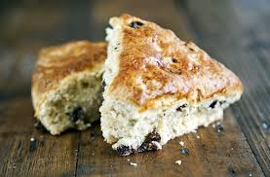
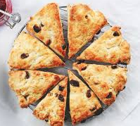
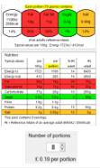
Image from Google Images
A little bit of science –
The baking powder will produce carbon dioxide gas to raise the scones.
When cooking we are assessing the skills the students are using and mastering. The skills this recipe focusses upon are –

Weighing, measuring, using electric whisk, mixing, shaping and moulding dough, rubbing in, resting, squeezing, even shaping, glazing, using the oven correctly and safely, testing for readiness, quality finish, following written instructions, washing and drying equipment, independence.

https://www.youtube.com/watch?v=e1LYWF8T8g0 – How to make butter – SciShow Kids
Container & Apron / Hair Tie
No nuts or nut-based ingredients.

- 250g self-raising flour (or ½ wholemeal & ½ self-raising to increase fibre)
- 1 small tub of double cream (250ml) to make the butter & buttermilk
- 50-80g butter – made from the cream!
- 100ml buttermilk – made from the cream!
- 1 tsp baking powder
- 100g grated cheese (or low-fat cheese / use less to reduce the saturated fat)
Let’s make butter and buttermilk
- Pour the double cream into a large bowl.
- Using an electric or hand whisk, whisk the cream until it separates into solids and liquid.
- Continue until the solids thicken – this is your butter!
- Squeeze out the excess buttermilk.
- Pour the liquid – buttermilk, into your measuring jug.
- Chill your butter before using OR chill your scones before cooking.
To make the scones –
- Preheat the oven to 180°C.
- Line a baking tray.
- Using your fingertips rub the butter into the flour until it resembles fine breadcrumbs.
- Add the baking powder
- Add your flavourings if using.
- Pour in the buttermilk a tablespoon at a time and mix to form a soft dough. Save a little of the buttermilk.
- Place the dough on a floured surface.
- Pat out the dough until 1.5cm thick.
- Shape into petticoat tails.
- Place the scones onto the baking
tray, brush the tops with a little
buttermilk and bake for 12-15
minutes until golden brown.
- After baking, place the scones
on a cooling rack.
Never assume a pan handle or oven tray is cold! You cannot tell by looking at it!

Buttermilk Scones
Bolognaise /Chilli con carne
https://www.youtube.com/watch?v=-gF8d-fitkU – Jamie Oliver Bolognaise – 5.27 minutes

Container with a lid & Apron / Hair Tie
No nuts or nut-based ingredients.
- 1 onion
- 1 can tomatoes
- 1 packet of mince (use lean meat to reduce the saturated fat) / lentils/ Quorn/ TVP
- 2 tablespoons tomato puree
- 1-2 cloves garlic – optional
- 1 teaspoon oregano / basil - optional
- 1 oxo cube - beef/vegetable (low salt versions are a good choice)
- ½ can water
- Vegetables of own choice – carrot / pepper / courgette / aubergine – aim for at least 2

For chilli con carne –
- chilli (fresh or dried/powder),
- 1 can red kidney beans (remember they contribute to 1 of your 5 a day)

- Chop, slice, and peel all ingredients set to one side – large bowl. Waste onto the tray.
- Dry fry the mince until it is golden brown, sieve off the excess fat and set to one side.
- Dry fry the vegetables until soft and golden (if they stick to the pan add a small amount of water). Remove from the pan and put back into the bowl.
- Put all ingredients into the pan – browned meat, the garlic, tomato puree, the tinned tomatoes, stock cube the herbs / spices and the water and any other ingredient using (kidney beans) and stir until the mixture is boiling.
- Turn down the heat and simmer for as long as possible or at least 15 minutes.
- Check for seasoning.
- At home – serve with whole meal pasta or brown rice to increase the fibre.

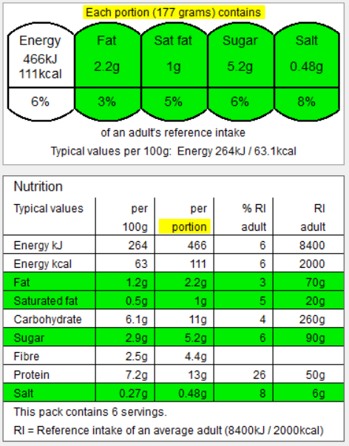
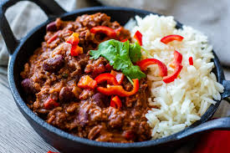
Image from Google images
Chilli
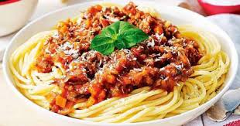

When cooking we are assessing the skills the students are using and mastering. The skills this recipe focusses upon are –
Transferring and embedding skills, simmering, knife skills (brunoise, macedoine, bridge, claw), draining, using the hob correctly and safely, handling and cooking high risk ingredients, testing for readiness, Maillard reaction, rendering fat, following written instructions, washing and drying equipment, independence.

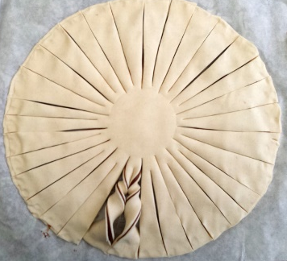
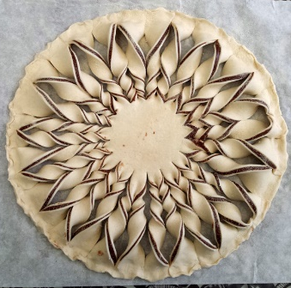
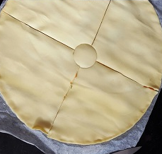
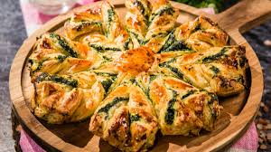

https://www.youtube.com/watch?v=ZIF-6CFsYxk – Beth’s Tarte Au Soleil, 5.25 minutes
Container with a lid or a baking tray with tinfoil / cling film & Apron / Hair Tie
No nuts or nut-based ingredients.

- 1 packet of ready rolled puff pastry
- 1 small onion
- 1 pepper
- 2-3 slices ham or chicken
- 150g cheese, grated
- 75g sweetcorn
- 1 egg, beaten (to glaze)
- 100ml tomato passata or 2 tbsp tomato pasta sauce
- Optional - 1 tsp paprika, ½ tsp hot chilli powder, 1 tsp dried mixed herbs or 1tsp chilli mix / fajita mix
- Optional - peppers, mushroom, asparagus, sweetcorn, olives, black beans.

  - Pre heat the oven to 200°C.
  - Unroll the pastry.
  - Using a small plate – cut out 2 circles.
  - Place one of the pastry circles onto the baking tray.
  - Spread over tomato passata- leaving a 1cm border around the edge of the pastry.
  - Add herbs and spices, onion, sweetcorn, peppers and chicken/ham.
  - Sprinkle with a layer of cheese.
  - Cover with the second layer of pastry.
  - Place a cup in the centre of the pastry and make 8 to 10 even cuts all the way around the pastry.
  - Brush on some beaten egg.
  - Twist each segment twice to make it resemble a sun like shape.
  - Bake for 20 minutes until golden brown.

When cooking we are assessing the skills the students are using and mastering. The skills this recipe focusses upon are –

Safe working within a food room, working in an organised approach, cleaning away, washing and drying, handling and rolling pastry, twisting and manipulating dough, bridge and claw technique, handling and preparing raw ingredients, timing and making judgements, pre-heating the oven, assessing when a food product is cooked.

Image from Google images
Mexican Sunshine
Chocolate Brownies

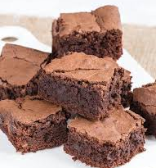

https://www.youtube.com/watch?v=KETPZPm6148 – 5.08 minutes, Jamie Oliver

These are to be eaten as a part of a balanced diet, as you can see by the ingredients they are not a healthy option, but there are always ways to make foods healthier to eat.
Brownie tin & Apron / Hair Tie
No nuts or nut-based ingredients

- 185g butter or margarine
- 185g dark chocolate – value/economy is good
- 85g plain flour (or wholemeal to increase fibre)
- 40g cocoa powder
- 3 eggs
- 275g sugar
- 50g white chocolate – optional
- 50g milk chocolate – optional

- Pre-heat the oven to 180°C.
- Line your tin with foil or baking paper.
- Put the 185g butter and 185g dark chocolate into a large bowl.
- Half fill a small saucepan with water, then sit the bowl on top so it rests on the rim of the pan, not touching the water.
- Heat over a low heat until the butter and chocolate have melted, stirring occasionally to mix, once melted take off the heat to allow to cool.
- Break 3 eggs into a large bowl and tip in 275g sugar, mix until thick and creamy, like a milk shake.
- Pour the eggy mousse over the cooled chocolate mixture, then gently fold together.
- Fold in the flour and cocoa powder, and other chocolate chunks if using.
- Pour the mixture into the prepared tin, scraping every bit out of the bowl with the spatula.
- Put in the oven and set your timer for 25 mins.
- If the brownie wobbles in the middle, it’s not quite done, bake for another 5 minutes until the top has a shiny, papery crust and the sides are just beginning to come away from the tin.
The brownies will remain in the tins and to be sliced into squares at home!

When cooking we are assessing the skills the students are using and mastering. The skills this recipe focusses upon are –

Transferring and embedding skills, how to prepare a baking tin, using the oven correctly, double boiler, chocolate work, whisking (aeration), coagulation (egg setting) testing for readiness, mixing, folding, preheating the oven, following written instructions, washing and drying equipment, independence.

Image from Google images
Double Boiler
Top Tip –
Check the water is not touching the bottom of the bowl – this may burn the chocolate.
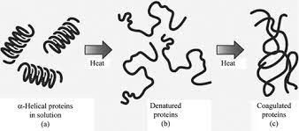
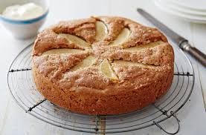
https://www.youtube.com/watch?v=kp2BBgqlHlQ– Amy Treasure, 0.47 minutes
Cake tin / brownie tin & Apron / Hair Tie
No nuts or nut-based ingredients

- 225g self-raising flour (or ½ wholemeal & ½ SR to increase fibre)
- 2 tsp ground cinnamon / nutmeg / mixed spice / ginger – optional
- 115g margarine/butter plus extra for greasing
- 115g sugar
- 2 large eggs
- 6-8 tbsp milk
- 225g apples / pears OR other fruits – canned / frozen / fresh – berries, peaches, banana
- 100g sultanas / dried fruit - optional
- 2 tbsp sugar to sprinkle over

The cake will remain in the cake tin and to be sliced at home!

- Heat the oven to 180°C.
- Grease and line a cake tin with baking parchment.
- Mix the flour and cinnamon together in a large bowl.
- Add the margarine/butter and rub into the flour using your fingers, until it resembles fine breadcrumbs.
- Stir in the light brown sugar.
- Beat in the egg followed by 6 - 8 tbsp of milk – you want to achieve a smooth, thick batter.
- Peel, core and grate the apples / pears.
- Add the apples and sultanas and mix to combine.
- Scrape the batter into your prepared tin and gently level out.
- Sprinkle over the extra sugar and bake in the oven for 30-40 minutes or until golden and a skewer inserted into the middle comes out clean.

When eggs are heated the runny yolk and white (albumen – which is the major source of protein) turn solid. The proteins in the egg start to thicken, a process known as coagulation. Egg whites coagulate at 60°C, egg yolks 65°C, with full coagulation occurring at 70°C.
This coagulation ‘sets’ the cake mixture.
https://www.ifst.org/
When cooking we are assessing the skills the students are using and mastering. The skills this recipe focusses upon are –

Weighing, measuring, handling high risk ingredients, lining a cake tin, mixing, shaping, rubbing in, knife skills - macedoine, coring, peeling, mixing, baking, using the oven correctly and safely, testing for readiness, following written instructions, washing and drying equipment, independence.

Image from Google images
Devonshire Apple Cake
Macaroni Cheese / Vegetable Bake
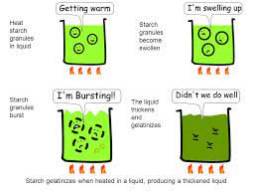
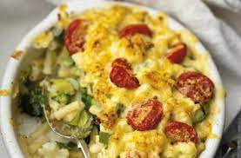
https://www.youtube.com/watch?v=9aeCJGmEXqE – Gordon Ramsey – 2.10 minutes

Container with a lid / oven dish & Apron / Hair Tie
No nuts or nut-based ingredients.
- 250g pasta (wholemeal will increase the fibre) or cauliflower / broccoli
- 40g butter (to lower the saturated fat you could try polyunsaturated margarine)
- 40g plain flour
- 1 pint milk – semi skimmed is good
- 250g grated cheddar (you could try low fat or low salt cheese)
- Optional extras - think – can I add at least 1 vegetable?
50g grated parmesan, sweetcorn, peas, carrots, cooked bacon, ham, tuna.

1. Cook the pasta / vegetables in a large saucepan of boiling water for 10 - 15 minutes; drain well and set aside. You want them to begin to go soft – remember they will cook again in the oven!
2. Melt the butter over a medium heat in a saucepan.
3. Add the flour and stir to form a roux - cook for 2 minutes.
4. Gradually whisk in the milk, a little at a time.
5. Cook for 10-15 minutes to a thickened and smooth sauce.
6. Remove the sauce from the hob, add ¾ of the cheese and stir until the cheese is well combined and melted.
6. Add the pasta / vegetables to the sauce and mix well. Transfer to a deep suitably-sized ovenproof dish.
7. Sprinkle over the remaining cheese.
At home – Bake at 180 °C for 20 -30 minutes or until piping hot.

When cooking we are assessing the skills the students are using and mastering. The skills this recipe focusses upon are –
Boiling, draining, making a bechamel sauce (gelatinisation), roux, grating, using the hob correctly and safely, mixing, knife skills if using vegetables – florets, jardinière, julienne, testing for readiness, following written instructions, washing and drying equipment, independence.

A little bit of science –
When starch is mixed with water and heated, the starch granules swell and eventually rupture, absorbing liquid, which thickens the mixture -this is gelatinisation.
On cooling, if enough starch is used, a gel forms. This process is used in the production of blancmange.

Image from Google images
Bread Art
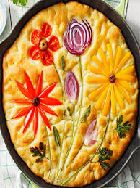
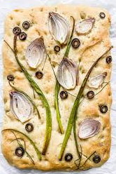
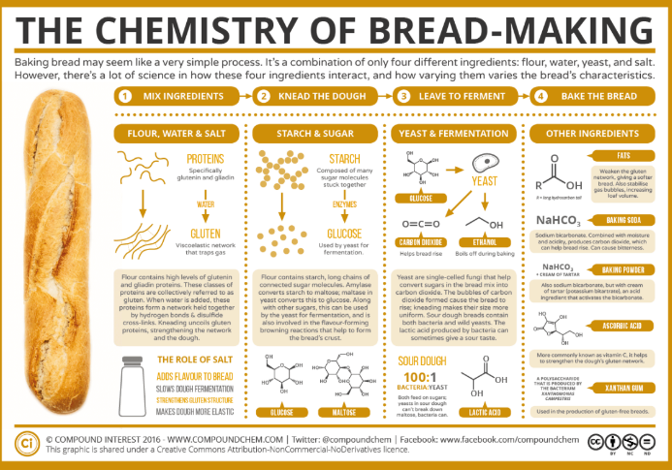
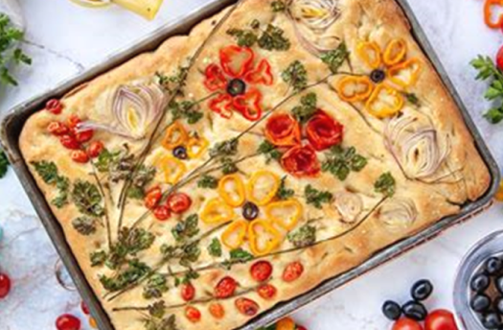
When cooking we are assessing the skills the students are using and mastering. The skills this recipe focusses upon are –
Transferring and embedding skills, knife skills (even sized chunks appropriate for cooking time, julienne, bridge, claw), how to prepare an onion, using the oven correctly and safely, grating, preparing vegetables, handling dough, rolling, shaping and moulding, proving, yeast-based dough, quality and evenness, testing for readiness, following written instructions, washing and drying equipment, independence.

Images from Google Images
Container /oven tray & Apron / Hair Tie
No nuts or nut-based ingredients

- 250g strong plain flour (or ½ wholemeal & half strong plain)
- 1 tsp sugar
- ½ tsp salt
- 2 tbsp olive oil – vegetable is fine to use
- 2 tsp yeast / 1 sachet
- ¼ pint warm water – from school

TOPPINGS –
- 1 tsp salt
- 2 tbsp olive oil
- Vegetables of your own choice –
onion, spring onion, garlic, peppers, mushrooms, courgette, asparagus, tomatoes, sweetcorn, chillies, olives, sundried tomatoes, capers.
Herbs – Rosemary, basil, chives, sage, thyme, etc.
- Pre-heat the oven to 50°C.
- In a large bowl put ALL of the; sugar, salt, oil, yeast and water but only HALF of the flour.
- Mix using the wooden spoon for 5 minutes.
- Add the last HALF of flour and stir in. You may need to either add more warm water OR more flour in order to make a slightly sticky but firm dough.
- Knead on a floured table for 15 minutes.
- Place the dough onto your oven tray and press out.
- Using your fingers DOCK the dough (press your fingers into the dough to make dimples).
- Smear over the olive oil and then the salt.
- Leave to prove in the oven on the low temperature.
- Whilst proving - prepare the vegetable toppings.
- Remove the bread from the oven. Turn oven up to 200°C.
- Using the vegetables, decorate the bread.
- Place into the hot oven and cook for 15 - 20 minutes.

