THE JOHN OF GAUNT SCHOOL
A COMMUNITY ACADEMY

YEAR 7 TRANSITION BOOKLET

Hello!

We are so pleased that you have chosen to join our school.

The Year 7 leadership team have enjoyed meeting some of you in your primary schools over the last couple of weeks and will try to get to all the primary schools before the Transition Day on the 5 July. Your teacher has been telling us how brilliant you are and we can’t wait to see you here altogether.

John of Gaunt is a great school. Fantastic learning takes place every day thanks to all the awesome teachers and the teamwork of students but we are also a school that likes to nurture the talents, interest and wellbeing of all our students. We have lots of extra-curricular activities taking place after school including, sports, music, STEM, drama, Photoshop and more (and they are all free!). There are various house competitions throughout the year such as the Spanish spelling bee and Sports Day. Some departments will organise trips or visiting speakers to come in to see us to enhance our learning and sometimes you might find Y7 and Y8 starting the day with mood boosting singing assembly.

Changing schools is daunting but you have a great team of people to look after you and some of them are shown on the next page.

Here’s a little bit more about the Year Leads:

My name is Mrs Addison. I joined The John of Gaunt School in 2014 and became the Head of Year 7 in 2017. I teach Maths, so some of you may have me as your teacher too. I have a daughter who is at primary school. We like to explore new places, eat ice cream, watch movies and join in with activities at our local church.

My name is Miss Lewis. I joined the school in 2019 and have worked with various year groups but my favourite is definitely Year 7. I currently play for Bath Ladies Rugby and teach PE here. One of my favourite things to do is to go to the theatre and I love watching live sports.
If you have any questions about the information in this booklet, email us at transition@jogschool.org. We would love to hear from you.

Mrs Addison and Miss Lewis
Year 7 Leads

KEY STAFF

Mrs S Stewart
Year 7 Pastoral Lead
Mrs E Addison
Year Head
Miss Z Lewis
Year Head

Mrs V Marshall
SENCO
Mrs S Hill
Pastoral Manager
Mrs H Kerr
Assistant Head Teacher
Inclusion & Safeguarding

Mr M Woodville
Headteacher in September

THE TUTOR TEAM

Students start each day with morning welcome in the Sports Hall at 8.35 am. Then they attend tutor time having a daily 20-minute tutor session between 8:45am and 9:05am where the tutor leads the daily activity of guided reading or another activity. Tutors will also check homework and be on hand for any questions or support your child may need.
In addition to tutor time activities, each week on a Friday, Year 7 students will have a whole year assembly.
There will be 9 tutor groups.
All students will be informed of both tutor and house on their induction day on Tuesday 5 July.
THE HOUSE SYSTEM
The student body of the school is divided into 4 houses.
We aim for each tutor group to have a mix of all four houses and if students have a sibling we will put them in the same house as them unless asked not to.
Our Houses are named after 4 famous scientists.
Franklin  House | Colour: Red | Rosalind Franklin was an English chemist. She is particularly famous for her work with X-Ray technology and discovering the structure of DNA
Greenfield House | Colour: Blue | Susan Greenfield is still alive and is a member of the House of Lords. Her recent work has focused in the treatment of Parkinson’s disease and Alzheimer’s disease
Hawking  House | Colour: Green | Stephen Hawking is a well-known physicist who has written a number of books, including his most well-known, ‘A Brief History of Time’. He is best known for his work with Black Holes and Relativity although some may know him from being on The Simpsons and Star Trek
Newton  House | Colour: Yellow | Sir Isaac Newton was a physicist and mathematician who is famous for his laws of physics including the laws of motion. Legend has it that he started to develop his understanding of the law of gravity after sitting under an apple tree and being hit on the head by an apple
Students have the John of Gaunt Falcon in their house colour on the lapel of their school shirt and their PE top has a flash of the house colour on the sides.
Throughout the year, there are many different competitions to gain points for your house, with the house cup being awarded at the end of the academic year to the House with the most points.
Competitions have previously included ‘Bake offs’, a photography competition, Inter house
sporting events, maths challenges and spelling bees. Reward points and good attendance can also contribute to overall House success.

THE SCHOOL DAY

School Gates Close | 8.30 am
Morning Welcome | 8.35 am in Sports Hall
Tutor Time | 8.45 – 9.05 am
Period 1 | 9.05 – 10.05 am
Period 2 | 10.05 – 11.05 am
Break | 11.05 to 11.25 am
Period 4 | 12.25 to 1.25 pm
Lunch | 1.25 to 2.00 pm
Period 5 | 2.00 to 3.00 pm
Students that arrive after the gates close at 8.30 am are required to sign in at the Student Reception where staff will be on hand to meet them.
3.00 pm onwards is when after school enrichment activities run, a few from the last year include:
- STEM Club
- Drama and the School Performance
- Astronomy
- Dungeons & Dragons
- Art
All enrichment activities are free and accessible to all. We encourage students to visit as many clubs and enrichment activities as possible to find those they really enjoy.

TRANSITION DAY
Tuesday 5 July 2022
Arrive in Wingfield Hall between 8.30 and 8.40 am
What to bring
Wear your current school uniform and trainers
Bring a pencil case
Completed biometric form (at the end of this booklet)
A bottle of water and a snack for break
What will we do?
On this day you will find out what tutor group and House you will be in.
You will meet the other students in your tutor group and do lots of activities to help you begin that journey into life at John of Gaunt.
We will provide a free lunch for all students
End of the Day
We will finish in Wingfield Hall at 2.30pm, so whoever is collecting you can meet you there.
Please bring a signed note if you have to meet a parent/carer somewhere else.
The Year 7 team will be around to answer any questions.

Parents’ Meeting Wingfield Hall 6.30pm
The Year 7 team and other key staff will share more information about policies and procedures at The John of Gaunt and what to expect in September. There will also be an opportunity to order uniform from Scholars or purchase good quality second-hand uniform.
If possible, students should not attend this meeting. Any questions you may have can be addressed with staff after the meeting.

HOMEWORK

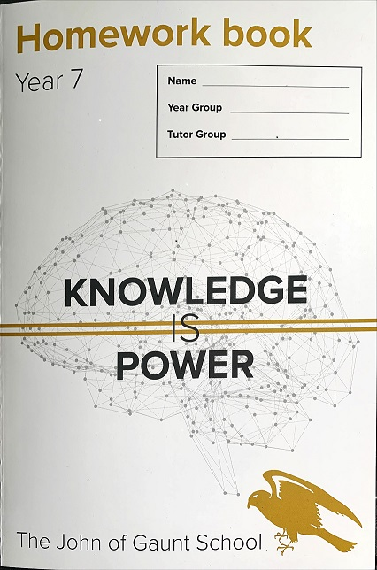

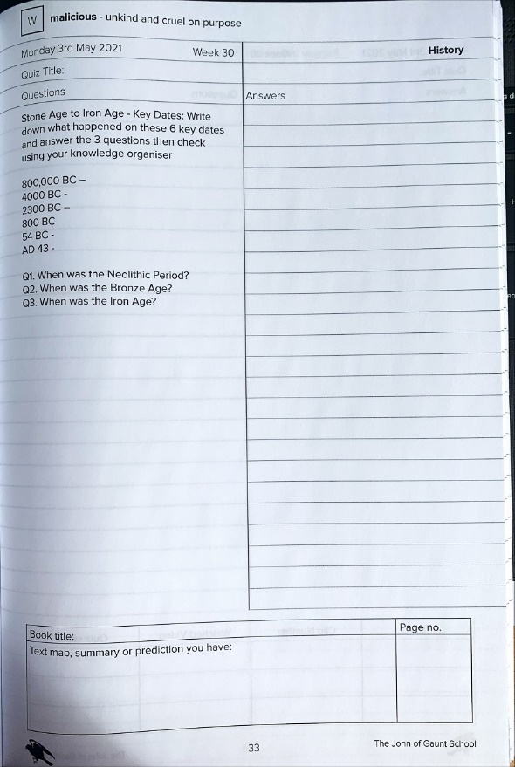

Year 7 students are expected to complete 1 hour of homework each evening.
The Power Hour requirements are as follows:
- 20 minutes Reading
- 20 minutes Self-quizzing (using the termly knowledge organiser)
- 20 minutes Hegarty Maths
The Power Hour is completed/recorded in a homework book which will be given out at the start of term. Tutors check the completion of homework every morning during morning welcome.
Guidance on how to successfully complete high-quality homework will be provided early in the school year.
Students may on occasion be set additional work such as preparation for an upcoming assessment. Instructions will be uploaded to Classcharts.

BEHAVIOUR FOR LEARNING
The John of Gaunt School’s behaviour for learning policy strives for disruption free learning and rewards those meeting our core values of ‘excellence, respect, responsibility, resilience and ambition’.
Students will be issued with a reminder if they are not meeting the expectations in lessons and in their free time; this is an opportunity to reflect and amend their behaviour.
Should a student continue to not meet the expectations, a warning is issued and students will be asked to attend the Pastoral Behaviour Support Centre immediately and remain there until 3:15pm.
The full policy is available on the school website.
Reward points and reminders will be added on Class Charts – Parents and Students will be issued with login details at the start of the school year. The app, which can be used on mobile devices and via a computer, allows the school to communicate with you, and for yourselves and your child to review their behaviour/reward points.

Reward points can be spent on a number of rewards. The rewards menu is also accessed via class charts.

EQUIPMENT

Students are expected to attend school fully equipped for their day, but we understand sometimes pencil cases may be forgotten. Basic equipment can therefore be supplied by the school during morning welcome. After the first occasion, there is a charge.
Maths pencil cases and basic equipment are also available for purchase through Faculty Admin.
Every Day Essentials:

Blue or black pen
Green pen
Pencil
Ruler
Sharpener
Rubber
Highlighter
Planner
Knowledge organiser
Earphones
Reading book
Subject specific
PE
PE kit as per uniform list
Spanish
Collins Easy Learning Dictionary
Food technology
Cooking ingredients
You will be given a list on Classcharts at least a week before.
Maths
Pair of compasses, Protractor and Calculator
Your teacher will tell you when you need to bring these things in.

For Art

(but also useful on other days)
Glue stick
Colouring pencils and felt tips
Rounded safety scissors
HB pencil
2B drawing pencil

Electronics

The John of Gaunt School is a mobile device free school. This means that students will not be allowed to have phones, wearable ‘smart watches’, headphones, non-learning tablets or mp3 style players out whilst on the school grounds. This operates between the hours of 8am and 5pm.
Students are allowed to use phones on some school trips if this has been agreed beforehand.
Students are asked to have their devices off or on silent whilst on the school property, including break and lunch times. If a device (including headphones) is seen or heard then staff will be asked to confiscate this until the end of the day.
The device will be stored in a safe in the year offices. The first time a device is confiscated during a term, it will be able to be collected at the end of the school day. Any subsequent times a parent must collect the phone or other nominated adult with a letter of authorisation from the parent or it will be held for 5 school days, whichever is sooner. If a student repeatedly abuses this rule we will ask parents to ensure that mobile phones are not brought to school.
The school has 3 phone hubs where students may go to make a call during non-lesson time such as break or lunchtime. These are the Year Pastoral Offices, Pitman and if necessary, it is also possible to ask to use a phone in reception. If a parent urgently needs to contact a child during the school day, we ask that you contact reception and we will ensure the message is given to your child. Also, we ask that you support your child and the school by not contacting them on their mobile device during the school day.
Please see the website for the most commonly asked questions regarding this policy.

UNIFORM

Students found not in the correct uniform for any reason will be asked to attend the Pastoral Behaviour Support Centre and borrow the correct pieces or remain there until items can be brought in for them.
A full uniform list is available on the school website. Please contact the Year Team if there are financial issues relating to the purchase of school uniform. This will be treated confidentially.
All students:
Trousers
Plain black only; full length, to at least the top of the shoe, plain material, classic tailored style with no extreme flares, trousers which are not overly tight. Leggings, footless tights, cords, jeans of any sort, cropped trousers or shorts are not allowed.
Skirts
The only skirt permitted is The John of Gaunt school skirt; a knee length skirt in dark grey plaid with twin pleats on the front and back. This can be purchased through Scholars. As a guide, the hem of the skirt should not be more than 6 cms (approx. 3 inches) off the ground when kneeling.
Sweatshirt
Plain Black with school logo jumper. Sweatshirts are not to be tucked in.
Polo shirt
Plain White polo shirt with falcon in house colour on collar, to be tucked into trousers or skirt if worn with sweatshirt/jumper.
Shoes
Plain black shoes only which are able to be polished. They should not resemble trainers or sports shoes. All other types of footwear are not allowed including trainers of any sort, ankle boots of any sort including ‘Doc Martin’ style boots. Daps, ‘Ugg’ boots, boots, open-toed sandals and decorated shoes are not allowed. Please do not wear shoes that ‘look’ like trainers as this may cause them to be questioned and if in doubt, we will consider them to be trainers.
Socks
Must be grey, black or white and plain.
Coats
Plain dark jackets and coats with a small logo are allowed. Hoodies of any sort are not allowed.
All students PE Kit:
- Grey and gold polo shirt
- Reversible rugby shirt or PE Hoodie (optional)
- Grey shorts or grey skort
- Grey leggings or tracksuit pants
- Grey football socks
- Training shoes with non-marking soles

- Base layer – plain black (optional)
- Football boots (optional)
Jewellery and make-up:
Students are allowed to wear a watch and one simple ring. Bracelets, neck chains and other such items are not allowed.
Pierced ears – one pair of small studs i.e. one in each ear is allowed. Studs are only allowed in the ear lobe. This applies to boys and girls.
Nose studs, eyebrow bars/studs, tongue piercings or any forms of body piercing are not allowed.
Jewellery of any type must not be worn during PE or games for health and safety reasons. The use of plasters to cover jewellery is not acceptable.
Students in years 7– 9 are not allowed to wear make-up.
Hairstyles should be appropriate i.e. smart, tidy, not at the extreme of fashion including no tram lines / fade, and the colour should look natural throughout. Long hair must be tied back during PE and practical work in Technology and Science.
Nail varnish and false nails/acrylics cannot be worn.
CANTEEN AND CASHLESS CATERING
The John of Gaunt School canteen operates a cashless system, where students pay using a prepaid account (which can be topped up via Parent Pay or with change in school) and a biometric thumb print system – permission forms are at the end of this pack.
Students that are eligible for Free School Meals will be set up on the school system. They will be allocated £2.60 per day. This will not show as a balance. Unspent money is NOT carried over. Should you have any queries please contact our finance team. Information regarding Free School Meals can be found both on the school and Wiltshire Council websites.
We aim to provide a varied menu which includes a good variety of foods including fresh meat, fresh vegetables, pulses and whole grains. We only have chips once a week and offer healthy options such as jacket potatoes, pasta pots and fresh fruit.
If you have a specific food allergy that is not met by our existing menu, please contact the Year Team to discuss.
Why use cashless catering?
- A faster and more efficient meal service
- Students do not need to bring cash to school
- Parents can be confident the money is being used as intended
- It removes the stigma of Free School Meals (FSM); their accounts are topped up automatically each day
- Detailed food and spending reports are available to parents through their ParentPay account

How are students recognised by the system?
- Biometrics - providing we receive parental consent, thumbprints are scanned; or
- PIN number - a unique Personal Identification Number (PIN) is allocated
Do all students need consent to use biometric recognition?
No, only students under 18.
Where do I send completed consent forms for the cashless catering?
These forms must be brought in on the Year 6 Induction Day. There is a form to complete at the end of this pack or forms can be downloaded from the school website: Biometric Permission slip

How are accounts charged for school meals?
- Biometrics - at the checkout, the student places their finger on a scanner or
- PIN - at the checkout, the student enters their unique PIN using a numeric pad

A screen will show the student’s name, photograph, class and current cash balance. The food items will be entered into the system from an itemised touch screen and then the amount spent and the new cash balance will be displayed.
How is money paid into meal accounts?
Every student and member of staff will have a meal account and purchases must be paid for in advance.

- Online via ParentPay, the School’s online payment system. ParentPay will accept debit card and credit card payments. Please note funds added this way could take up to 30 minutes to appear in meal accounts. If you would like information about using ParentPay, please contact Mrs Gray in the Finance Office on 01225 711164.
- Students may top-up their meal accounts using cash (coins and notes) at the cash loader machine located in the canteen. The cash loader will accept: £20, £10 and £5 notes and £2, £1, 50p, 20p, 10p and 5p coins. Cash is not accepted at any till.
- We strongly recommend that students do not bring large sums of cash into school.
How will parents and students check balances?
- Parents can log onto their ParentPay account to view the balances on their children’s meal accounts
- Students can see their balances on the cash loading devices. They are not required to deposit funds to view balances.
Is there a limit on the amount students can spend each day?
The default daily limit is £5. Parents may instruct the school to set a higher or lower limit in one of the following ways:
- Indicate the preferred amount on the biometric permission letter
- Send a signed letter or note addressed to the “Finance Office”
- Email payments@jogschool.org

How much should I pay into meal accounts?
Meal accounts can be topped up daily, weekly, monthly or termly. It is up to you to decide the amount that is sufficient for your child. If you are giving your child cash, they will need to use the cash loader machine before they can make any purchases, so it may be advisable to do this weekly as we only have one cash loader on site. A “meal deal” with a main meal and dessert or a main meal and drink is approximately £2.60.

A daily spend limit can be set to ensure funds added to the meal account last for the intended period (see previous question). Again, please bear in mind that payments via ParentPay can take up to 30 minutes to reach meal accounts.
What if the student does not hold sufficient balance to cover their purchases?
The school retains the right to refuse a school meal if a student has insufficient credit or if they forget to bring their lunch money to school. The school will not allow the student to overdraw their account. However, we will endeavour to make allowances for this on the understanding that parents will be expected to ensure the account is settled by the next day or contact the school if there is a delay. Please contact Mrs Gray in the Finance office in this instance.
Why does the school want parents to use ParentPay instead of cash?
- Online payment is more convenient and secure
- Parents can pay in advance: by the week, month, term, whatever suits them best
- Parents can see how much is left on meal accounts at any time either from home, work or smartphone – anywhere they have access to the internet
- Students cannot lose or forget their dinner money
- Students do not have to use their free time to queue at cash loader machines to top-up meal accounts
- Funds can only be spent at the school catering outlets and parents can be confident that dinner money is not used for other purposes
- Parents are able to see what their children are buying, parents without internet access can request a print-out at any time from the Finance office
Why does the school prefer students to use biometric recognition?
- Security – biometric recognition is more secure than a PIN number
- Convenience – students do not need to remember their PIN
- Efficiency – quicker than using PIN numbers
What about students entitled to Free School Meals (FSM)?
The amount allocated for FSM will automatically be credited each day and may be used whenever the catering facilities are open. Any underspend or missed dinner will not be accumulated. Students may add extra cash to their meal accounts by using the cash loader devices; enabling a greater daily spend than allocated by their free meal allowance. Parents may also top up funds using ParentPay. The system will first deduct the free school meal allowance before deducting funds added by students and parents. There is no difference in the way the system is used by FSM students and anyone else. They will remain completely anonymous and catering staff and other students will not be able to identify FSM students who use the catering facilities. **Please note that bottled drinks are not included in the FSM entitlement and are chargeable.
What about Data Protection?
Certain data will be held on the system to enable accurate operation. This will include your child’s name, class, account balance and meal entitlement. This data will be managed in compliance with the Data Protection Act (GDPR from May 2018) and Protection of Freedoms Act and will only be used in the operation of the cashless meal system. Fingerprints are not stored on the system and none of the information is made available to third parties.
Tell me more about Biometrics
Biometrics are widely used and accepted in thousands of schools in the UK.
New laws on the use of Biometrics in Schools were introduced in September 2012, under the Protection of Freedoms Act 2012. The Biometric system at The John of Gaunt School complies with the provisions and requirements of the new legislation.

Your child's thumbprint is scanned; the software selects several points of the thumbprint; like landmarks on a map. It then takes the co-ordinates of only these specific points and passes them through software that turns them into a numeric code. The image of the thumbprint is never stored. It is impossible to recreate a thumbprint using the code. The codes are only recognised by The John of Gaunt’s cashless catering system and are useless to any third parties.

The school must obtain the permission of parents and students to enable students to use the biometric recognition system. The school uses a secondary system (PIN numbers) for students who do not opt-in to the biometric system.

The data will not be transferred to any third party and will be automatically deleted once your child leaves The John of Gaunt School.

ATTENDANCE AND APPOINTMENTS

There is a link between good school attendance and high-level attainment. Regardless of the reason, if your child is absent from school it will impact on their learning. Parents/carers are legally responsible for ensuring their child attends school on time every day. Government guidance set an attendance target of a minimum of 95%.
Medical Appointments
Where possible all appointments should be booked outside of school hours. Where this is not possible, the amount of school time missed must be kept to a minimum. School may not authorise the time off school if medical evidence is not provided.
Too ill to attend school?
Children can attend school with minor ailments (toothache, headache, stomach ache, cold, sore throat). Over the counter medicines can be given before school. School will contact you if they become too ill to remain in school.
Children should be off school for 48 hours if they have diarrhoea or vomiting. If you are unsure how long your child should be absent with an illness speak to your child’s school, your doctor or your pharmacist for advice.
Unauthorised Leave in Term Time (Holidays)
Children are not entitled to holidays in term time. Family holidays should be taken during school holiday periods.
Requests for leave due to exceptional circumstances preventing the period of leave being taken during school holidays must be made in writing to the Headteacher.
Reporting Absence
It is a parent/carer’s responsibility to notify school if their child is absent BEFORE school starts at 8.35 am. A reason must be provided.
You can contact school using our online school Gateway system or calling our absence line.
Notification of a student absence
Telephone: 01225 762637
Email: absence@jogschool.org

MEDICATIONS

Students with medical needs requiring medication during school hours will need to keep this in First Aid with a completed and up to date medication form. You will find a medication form in this pack.
Medication forms can be collected from Reception or the Year office.
Staff cannot administer medication without a completed, up to date form and parental consent.

USEFUL CONTACTS

The John of Gaunt uses both School Comms and Class Charts to communicate with parents but you may find the below details helpful.
Staff can be contacted on email, and school emails follow the format of first initial followed by surname @jogschool.org
E.g. aname@jogschool.org
A full list of staff is available on the school website.
Subject specific queries
- The subject teacher
Other concerns or queries in the first instance
- The tutor
The Year Team
Mrs H Kerr Assistant Head Teacher and SLT link for Year 7
Mrs E Addison – Year Head
Miss Z Lewis – Year Head
Mrs S Stewart – Pastoral Lead for Year 7
Attendance 01225 762637
absence@jogschool.org Miss L Kilford – Attendance Officer
Finance 01225 711165
Reception 01225 762637 Mrs N Lee - Receptionist
Appointments with staff
We know that there are times when a parent or carer needs to see a member of staff in person.
Wherever possible we ask that you contact the school before coming in as staff may be teaching or have other commitments, which mean they are not free to see parents and carers immediately. This can result in a wasted journey or a lengthy wait.

